Chapter 7. Advanced Spanning Tree
The authors would like to thank Radia Perlman for graciously contributing her time to review the material in this chapter.
This chapter covers the following key topics:
- Typical Campus Design: A Baseline Network—
Introduces a baseline network for use throughout most of the chapter.
- STP Behavior in the Baseline Network: A Spanning Tree Review—
Reviews the concepts introduced in Chapter 6, "Understanding Spanning Tree," while also introducing some advanced STP theory.
- Spanning Tree Load Balancing—
Master this potentially confusing and poorly documented feature that can double available bandwidth for free. Four Spanning Tree load balancing techniques are discussed in detail.
- Fast STP Convergence—
Seven techniques that can be used to improve on the default STP failover behavior of 30–50 seconds.
- Useful STP Display Commands—
Several commands that can be extremely useful for understanding and troubleshooting STP's behavior in your network.
- Per-VLAN Spanning Tree Plus (PVST+)—
An important feature introduced by Cisco, PVST+ allows interoperability between traditional per-VLAN Spanning Tree (PVST) Catalysts and devices that support 802.1Q.
- Disabling STP—
Explains how to disable Spanning Tree on Catalyst devices. Also considers reasons why this might be done and why it shouldn't be done.
- Tips and Tricks: Mastering STP—
A condensed listing of Spanning Tree advice to help you avoid STP problems in your network.
Chapter 6, "Understanding Spanning Tree," constructed a solid foundation of Spanning Tree knowledge. This chapter builds on that base by looking at a variety of advanced issues related to the Spanning-Tree Protocol (STP). After a quick review of some key points from Chapter 6, the discussion examines the important issue of load balancing. The techniques discussed in this section might allow you to double your available bandwidth in a redundant configuration without buying any new equipment! The chapter then discusses methods for improving Spanning Tree convergence and failover times. After a detailed look at some important show commands and new features, the chapter concludes with a section called "Tips and Tricks: Mastering STP." This information is designed to be a compendium of useful Spanning Tree information and best practices.
If you skipped Chapter 6, "Understanding Spanning Tree," consider that some of the techniques discussed in this chapter are not intuitively obvious. For example, a good understanding of STP basics is required to comprehend Spanning Tree load balancing. At the very least, I recommend that you do the exercises located at the end of Chapter 6. If these seem straightforward, by all means, continue. However, if they seem strange and mysterious, you might want to go back and read Chapter 6.
Caution
As with Chapter 6, the examples in this chapter are designed to illustrate the intricacies of the Spanning-Tree Protocol, not good design practices. For more information on Spanning Tree and campus design principles, please refer to Chapter 11, "Layer 3 Switching," Chapter 14, "Campus Design Models," Chapter 15, "Campus Design Implementation," and Chapter 17, "Case Studies: Implementing Switches."

Typical Campus Design: A Baseline Network
Chapter 14, "Campus Design Models," takes a detailed look at overall campus design principals. Although there are many options available when laying out a campus network, most are some variation of the network illustrated in Figure 7-1.

Figure 7-1 Typical Design for a Single Building in a Switched Campus Network
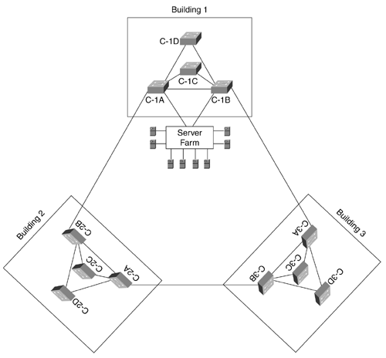
Figure 7-1 shows a network that might be contained within several buildings of a large campus environment. The PCs and workstations directly connect on one of the Intermediate Distribution Frame (IDF) switches located on every floor. These IDF switches also link to Main Distribution Frame (MDF) switches that are often located in the building's basement or ground floor. Because the MDF is carrying traffic for the entire building, it is usually provisioned with a pair of redundant switches for increased bandwidth and reliability. The MDF switches then connect to the rest of the campus backbone where a server farm is generally located.
By looking at this network from the point of view of a single IDF wiring closet, much of the complexity can be eliminated as shown in Figure 7-2.

Figure 7-2 Typical Campus Network Simplified to Show a Single IDF
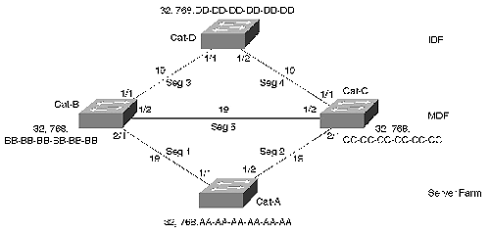
By reducing the clutter of multiple IDFs and MDFs, Figure 7-2 allows for a much clearer picture of what is happening at the Spanning Tree level and focuses on the fact that most campus designs utilize triangle-shaped STP patterns. (These patterns and their impact on campus design are discussed in detail during Chapters 14, 15, and 17.) Furthermore, because modern traffic patterns tend to be highly centralized, it eliminates the negligible level of IDF-to-IDF traffic present in most networks.
Note
Chapter 14 discusses the differences between two common campus design modules: the campus-wide VLANs model and the multilayer model. In campus-wide VLANs, the network consists of many large and overlapping triangle- and diamond-shaped patterns that can be simplified in the manner shown in Figure 7-2. Because these triangles and diamonds overlap and interconnect, it often leads to significant scaling problems. The multilayer model avoids these issues by using Layer 3 switching (routing) to break the network into many small triangles of Layer 2 connectivity. Because these triangles are isolated by the Layer 3 switching component, the network is invariably more scalable.
A detailed discussion of the differences between these two models is beyond the scope of this chapter. Obviously, consult Chapter 14 for more information. However, it is worth noting that this chapter often uses examples from the campus-wide VLANs model because they present more Spanning Tree challenges and opportunities. Nevertheless, you should generally consider using Layer 3 switching for reasons of scalability.

Cat-D in Figure 7-2 is an IDF switch that connects to a pair of MDF switches, Cat-B and Cat-C. The MDF switches connect through the campus backbone to a server farm switch, Cat-A.
Tip
Utilize this technique of simplifying the network when trying to understand STP in your network. When doing this, be sure to include paths where unusually heavy traffic loads are common. Having a modular design where a consistent layout is used throughout the network can make this much easier (see Chapters 14 and 15 for more information).

STP Behavior in the Baseline Network: A Spanning Tree Review
This section analyzes Spanning Tree's default behavior in a network such as that in Figure 7-2. Not only does this serve as a useful review of the material in Chapter 6, it provides a baseline network that can be used throughout the remainder of this chapter. In doing so, the text makes no attempt to be an exhaustive tutorial—it is only capturing the critical and easily missed aspects of the protocol (see Chapter 6 for a more complete discussion of Spanning Tree basics).

General BPDU Processing
Recall from Chapter 6 that bridges share information using Bridge Protocol Data Units (BPDUs). There are two types of BPDUs:
- Configuration BPDUs—
Account for the majority of BPDU traffic and allow bridges to carry out STP elections
- Topology Change Notification (TCN) BPDUs—
Assist in STP failover situations
When people use the term BPDU without indicating a specific type, they are almost always referring to a Configuration BPDU.

Determining the Best Configuration BPDU
Every bridge port running the Spanning-Tree Protocol saves a copy of the best Configuration BPDU it has seen. In doing this, the port not only considers every BPDU it receives from other bridges, but it also evaluates the BPDU that it would send out that port.
To determine the best Configuration BPDU, STP uses a four-step decision sequence as follows:
Step 1. The bridges look for the lowest Root Bridge Identifier (BID), an eight-byte field composed of a Bridge Priority and a Media Access Control (MAC) address. This allows the entire bridged network to elect a single Root Bridge.
Step 2. The bridges consider Root Path Cost, the cumulative cost of the path to the Root Bridge. Every non-Root Bridge uses this to locate a single, least-cost path to the Root Bridge.
Step 3. If the cost values are equal, the bridges consider the BID of the sending device.
Step 4. Port ID (a unique index value for every port in a bridge or switch) is evaluated if all three of the previous criteria tie.
Tip
A shortened, easy-to-remember outline of the four-step STP decision sequence to determine the best Configuration BPDU is as follows:
Step 1. Lowest Root BID
Step 2. Lowest Root Path Cost
Step 3. Lowest Sending BID
Step 4. Lowest Port ID

As long as a port sees its own Configuration BPDU as the most attractive, it continues sending Configuration BPDUs. A port begins this process of sending Configuration BPDUs in what is called the Listening state. Although BPDU processing is occurring during the Listening state, no user traffic is being passed. After waiting for a period of time defined by the Forward Delay parameter (default=15 seconds), the port moves into the Learning state. At this point, the port starts adding source MAC addresses to the bridging table, but all incoming data frames are still dropped. After another period equal to the Forward Delay, the port finally moves into the Forwarding state and begins passing end-user data traffic. However, if at any point during this process the port hears a more attractive BPDU, it immediately transitions into the Blocking state and stops sending Configuration BPDUs.

Converging on an Active Topology
Configuration BPDUs allow bridges to complete a three-step process to initially converge on an active topology:
Step 1. Elect a single Root Bridge for the entire Spanning Tree domain.
Step 2. Elect one Root Port for every non-Root Bridge.
Step 3. Elect one Designated Port for every segment.
First, the bridges elect a single Root Bridge by looking for the device with the lowest Bridge ID (BID). By default, all bridges use a Bridge Priority of 32,768, causing the lowest MAC address to win this Root War. In the case of Figure 7-2, Cat-A becomes the Root Bridge.
Tip
As with all Spanning Tree parameters, the lowest numeric Bridge ID value represents the highest priority. To avoid the potential confusion of lowest value and highest priority, this text always refers to values (in other words, the lower amount is preferred by STP).

Second, every non-Root Bridge elects a single Root Port, its port that is closest to the Root Bridge. Cat-B has to choose between three ports: Port 1/1 with a Root Path Cost of 57, Port 1/2 with a cost of 38, or Port 2/1 with a cost of 19. Obviously, Port 2/1 is the most attractive and becomes the Root Port. Similarly, Cat-C chooses Port 2/1. However, Cat-D calculates a Root Path Cost of 38 on both ports—a tie. This causes Cat-D to evaluate the third decision criterion—the Sending BID. Because Cat-B has a lower Sending BID than Cat-C, Cat-D:Port-1/1 becomes the Root Port.
Finally, a Designated Port is elected for every LAN segment (the device containing the Designated Port is referred to as the Designated Bridge). By functioning as the only port that both sends and receives traffic to/from that segment and the Root Bridge, Designated Ports are the mechanism that actually implement a loop-free topology. It is best to analyze Designated Port elections on a per-segment basis. In Figure 7-2, there are five segments. Segment 1 is touched by two bridge ports—Cat-A:Port-1/1 at a cost of zero and Cat-B:Port-2/1 at a cost of 19. Because the directly-connected Root Bridge has a cost of zero, Cat-A:Port-1/1 obviously becomes the Designated Port. A similar process elects Cat-A:Port-1/2 as the Designated Port for Segment 2. Segment 3 also has two bridge ports: Cat-B:Port-1/1 at a cost of 19 and Cat-D:Port-1/1 at a cost of 38. Because it has the lower cost, Cat-B:Port-1/1 becomes the Designated Port. Using the same logic, Cat-C:Port-1/1 becomes the Designated Port for Segment 4. In the case of Segment 5, there are once again two options (Cat-B:Port-1/2 and Cat-C:Port-1/2), however both are a cost of 19 away from the Root Bridge. By applying the third decision criterion, both bridges determine that Cat-B:Port-1/2 should become the Designated Port because it has the lower Sending BID.
Figure 7-3 shows the resulting active topology and port states.

Figure 7-3 Active Topology and Port States in the Baseline Network
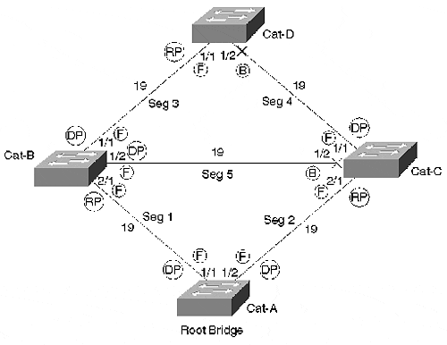
Two ports remain in the Blocking state: Cat-C:Port-1/2 and Cat-D:Port-1/2. These ports are often referred to as non-Designated Ports. They provide a loop-free path from every segment to every other segment. The Designated Ports are used to send traffic away from the Root Bridge, whereas Root Ports are used to send traffic toward the Root Bridge.
Note
From a technical perspective, it is possible to debate the correct ordering of Steps 2 and 3 in what I have called the 3-Step Spanning Tree Convergence Process. Because 802.1D (the Spanning Tree standards document) specifically excludes Designated Ports from the Root Port election process, the implication is that Designated Ports must be determined first. However, 802.1D also lists the Root Port selection process before the Designated Port selection process in its detailed pseudo-code listing of the complete STP algorithm. This text avoids such nerdy debates. The fact of the matter is that both occur constantly and at approximately the same time. Therefore, from the perspective of learning how the protocol operates, the order is irrelevant.

In addition to determining the path and direction of data forwarding, Root and Designated Ports also play a key role in the sending of BPDUs. In short, Designated Ports send Configuration BPDUs, whereas Root Ports send TCN BPDUs. The following sections explore the two types of BPDUs in detail.

Configuration BPDU Processing
Configuration BPDUs are sent in three cases. The discussion that follows breaks these into two categories, normal processing and exception processing. (This terminology is non-standard, but useful for understanding how STP works.)

Normal Configuration BPDU Processing
Normal processing occurs every Hello Time seconds on all ports of the Root Bridge (unless there is a physical layer loop). This results in the origination of Configuration BPDUs at the Root Bridge.
Normal processing also occurs when a non-Root Bridge receives a Configuration BPDU on its Root Port and sends an updated version of this BPDU out every Designated Port. This results in the propagation of Configuration BPDUs away from the Root Bridge and throughout the entire Layer 2 network.
These two conditions account for the normal flow of Configuration BPDUs that constantly stream away from the Root Bridge during steady state processing. The Root Bridge originates Configuration BPDUs on its Designated Ports every two seconds (the default value of Hello Time). Note that every active port on the Root Bridge should be a Designated Port unless there is a physical layer loop to multiple ports on this bridge. As these Configuration BPDUs arrive at the Root Ports of downstream bridges, these bridges then propagate Configuration BPDUs on their Designated Ports. Figure 7-4 illustrates how this process propagates Configuration BPDUs away from the Root Bridge.

Figure 7-4 Normal Sending of Configuration BPDUs
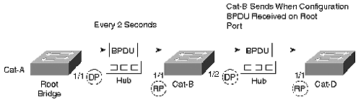
Figure 7-4 shows Cat-A, the Root Bridge, originating Configuration BPDUs every two seconds. As these arrive on Cat-B:Port-1/1 (the Root Port for Cat-B), Configuration BPDUs are sent out Cat-B's Designated Ports, in this case Port 1/2.
Several observations can be made about the normal processing of Configuration BPDUs:
- Configuration BPDUs flow away from the Root Bridge.
- Root Ports receive Configuration BPDUs.
- Root Ports do not send Configuration BPDUs.
- Blocking ports do not send Configuration BPDUs.
- If the Root Bridge fails, Configuration BPDUs stop flowing throughout the network. This absence of Configuration BPDUs continues until another bridge's Max Age timer expires and starts taking over as the new Root Bridge.
- If the path to the Root Bridge fails (but the Root Bridge is still active), Configuration BPDUs stop flowing downstream of the failure. If an alternate path to the Root Bridge is available, this absence of Configuration BPDUs continues until another path is taken out of the Blocking state. If an alternate path to the Root Bridge is not available, the bridged network has been partitioned and a new Root Bridge is elected for the isolated segment of the network.
Therefore, under the normal behavior, a non-Root Bridge only sends Configuration BPDUs when a Root Bridge-originated BPDU arrives on its Root Port.

Exception Configuration BPDU Processing
Exception Configuration BPDU processing, by contrast to normal processing, occurs when a Designated Port hears an inferior BPDU from some other device and sends a Configuration BPDU in response. The Spanning Tree algorithm includes this exception processing to squelch less attractive information as quickly as possible and speed convergence. For example, consider Figure 7-5 where the Root Bridge failed (Step 1 in the figure) just before Cat-C was connected to the Ethernet hub (Step 2 in the figure).

Figure 7-5 The Root Bridge Failed Just Before Cat-C Was Connected
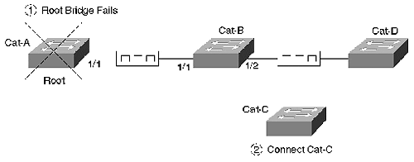
Figure 7-6 illustrates the conversation that ensues between Cat-C and Cat-B.

Figure 7-6 Exception Processing of Configuration BPDUs
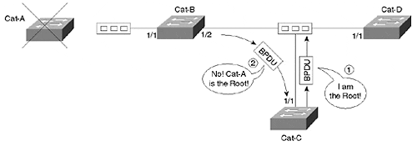
As discussed in Chapter 6, Cat-C initially assumes it is the Root Bridge and immediately starts sending BPDUs to announce itself as such. Because the Root Bridge is currently down, Cat-B:Port-1/2 has stopped sending Configuration BPDUs as a part of the normal processing. However, because Cat-B:Port-1/2 is the Designated Port for this segment, it immediately responds with a Configuration BPDU announcing Cat-A as the Root Bridge. By doing so, Cat-B prevents Cat-C from accidentally trying to become the Root Bridge or creating loops in the active topology.
The sequence illustrated in Figure 7-6 raises the following points about Configuration BPDU exception processing:
- Designated Ports can respond to inferior Configuration BPDUs at any time.
- As long as Cat-B saves a copy of Cat-A's information, Cat-B continues to refute any inferior Configuration BPDUs.
- Cat-A's information ages out on Cat-B in Max Age seconds (default=20 seconds). In the case of Figure 7-5, Cat-B begins announcing itself as the Root Bridge at that time.
- By immediately refuting less attractive information, the network converges more quickly. Consider what might happen if Cat-B only used the normal conditions to send a Configuration BPDU—Cat-C would have 20 seconds to incorrectly assume that it was functioning as the Root Bridge and might inadvertently open up a bridging loop. Even if this did not result in the formation of a bridging loop, it could lead to unnecessary Root and Designated Port elections that could interrupt traffic and destabilize the network.
- Because Cat-D:Port-1/1 is not the Designated Port for this segment, it does not send a Configuration BPDU to refute Cat-C.
Tip
Configuration BPDUs are sent in three cases:
- When the Hello Timer expires (every two seconds by default), the Root Bridge originates a Configuration BPDU on every port (assuming no self-looped ports). This is a part of the normal Configuration BPDU processing.
- When non-Root Bridges receive a Configuration BPDU on their Root Port, they send (propagate) updated Configuration BPDUs on all of their Designated Ports (normal processing).
- When a Designated Port hears an inferior Configuration BPDU from another switch, it sends a Configuration BPDU of its own to suppress the less attractive information.

TCN BPDU Processing
Whereas Configuration BPDUs are the general workhorse of the STP algorithm, TCN BPDUs perform a very specific role by assisting in network recovery after changes in the active topology. When a non-Root Bridge detects a change in the active topology, a TCN BPDU is propagated upstream through the network until the Root Bridge is reached. The Root Bridge then tells every bridge in the network to shorten their bridge table aging periods from 300 seconds to the interval specified by Forward Delay. In other words, TCN BPDUs are used to tell the Root Bridge that the topology has changed so that Configuration BPDUs can be used to tell every other bridge of the event.
TCN BPDUs are sent in three cases. It is useful to group these into two categories, change detection and propagation:
- Change detection—
Occurs in the event that a bridge port is put into the Forwarding state and the bridge has at least one Designated Port. Change detection also occurs when a port in the Forwarding or Learning states transitions to the Blocking state.
- Propagation—
Occurs in the event that a non-Root Bridge receives a TCN (from a downstream bridge) on a Designated Port.
The first two conditions categorized under change detection constitute a change in the active topology that needs to be reflected in bridging tables throughout the network. The last condition is used to propagate TCN BPDUs up through the branches of the Spanning Tree until they reach the Root Bridge.
Tip
TCN BPDUs are sent in three cases:
- When a port is put in the Forwarding state and the bridge has at least one Designated Port (this is a part of change detection).
- When a port is transitioned from the Forwarding or Learning states back to the Blocking state (change detection).
- When a TCN BPDU is received on Designated Port, it is forwarded out the bridge's Root Port (propagation).

Several observations can be made about TCN BPDUs:
- TCN BPDUs are only sent out Root Ports.
- TCN BPDUs are the only BPDUs sent out Root Ports (Configuration BPDUs are only sent out Designated Ports, not Root Ports).
- TCN BPDUs are received by Designated Ports.
- TCN BPDUs flow upstream toward the Root Bridge.
- TCN BPDUs use a reliable mechanism to reach the Root Bridge. When a bridge sends a TCN BPDU, it continues repeating the BPDU every Hello Time seconds until the upstream bridge acknowledges receipt with a Topology Change Acknowledgement flag in a Configuration BPDU. TCN BPDUs are not periodic in the same sense as Configuration BPDUs. Other than the retransmission of already generated TCN BPDUs discussed in the previous bullet and used as a reliability mechanism, completely new TCN BPDUs are not sent until the next topology change occurs (this could be hours, days, or weeks later).
- TCN BPDUs are acknowledged even if the normal Configuration BPDU processing discussed earlier has stopped (because the flow of Configuration BPDUs from the Root Bridge has stopped flowing).
Tip
The TCN process is discussed in considerably more detail in Chapter 6 (see the section "Topology Change Notification BPDUs").

STP Timers
The Spanning-Tree Protocol provides three user-configurable timers: Hello Time, Forward Delay, and Max Age. To avoid situations where each bridge is using a different set of timer values, all bridges adopt the values specified by the Root Bridge. The current Root Bridge places its timer values in the last three fields of every Configuration BPDU it sends. Other bridges do not alter these values as the BPDUs propagate throughout the network. Therefore, timer values can only be adjusted on Root Bridges.
Tip
Avoid the frustration of trying to modify timer values from non-Root Bridges—they can only be changed from the Root Bridge. However, do not forget to modify the timer values on any backup Root Bridges so that you can keep a consistent set of timers even after a primary Root Bridge failure.

The Hello Time timer is used to control the sending of BPDUs. Its main duty is to control how often the Root Bridge originates Configuration BPDUs; however, it also controls how often TCN BPDUs are sent. By repeating TCN BPDUs every Hello Time seconds until a Topology Change Acknowledgement (TCA) flag is received from the upstream bridge, TCN BPDUs are propagated using a reliable mechanism. 802.1D, the Spanning Tree standard document, specifies an allowable range 1–10 seconds for Hello Time. The syntax for changing the Hello Time is as follows (see the section "Lowering Hello Time to One Second" for more information):

set spantree hello interval [vlan]

The Forward Delay timer primarily controls the length of time a port spends in the Listening and Learning states. It is also used in other situations related to the topology change process. First, when the Root Bridge receives a TCN BPDU, it sets the Topology Change (TC) flag for Forward Delay+Max Age seconds. Second, this action causes all bridges in the network to shorten their bridge table aging periods from 300 seconds to Forward Delay seconds. Valid Forward Delay values range from 4–30 seconds with the default being 15 seconds. To change the Forward Delay, use the following command (see the section "Tuning Forward Delay" for more information):

set spantree fwddelay delay [vlan]

The Max Age timer controls the maximum length of time that a bridge port saves Configuration BPDU information. This allows the network to revert to a less attractive topology when the more attractive topology fails. As discussed in the previous paragraph, Max Age also plays a role in controlling how long the TC flag remains set after the Root Bridge receives a TCN BPDU. Valid Max Age values are 6 to 40 seconds with the default being 20 seconds. The command for changing the Max Age time is shown in the following (see the section "Tuning Max Age" for more information):

set spantree maxage agingtime [vlan]

Configuration BPDUs also pass a fourth time-related value, the Message Age field (don't confuse this with Max Age). The Message Age field is not a periodic timer value—it contains the length of time since a BPDU's information was first originated at the Root Bridge. When Configuration BPDUs are originated by the Root Bridge, the Message Age field contains the value zero. As other bridges propagate these BPDUs through the network, the Message Age field is incremented by one at every bridge hop. Although 802.1D allows for more precise timer control, in practice, bridges simply add one to the existing value, resulting in something akin to a reverse TTL. If connectivity to the Root Bridge fails and all normal Configuration BPDU processing stops, this field can be used to track the age of any information that is sent during this outage as a part of Configuration BPDU exception processing discussed earlier.
The Spanning-Tree Protocol also uses a separate Hold Time value to prevent excessive BPDU traffic. The Hold Time determines the minimum time between the sending of any two back-to-back Configuration BPDUs on a given port. It prevents a cascade effect of where BPDUs spawn more and more other BPDUs. This parameter is fixed at a non-configurable value of one second.

How Far Does Spanning Tree Reach?
It is important to note the impact of placing routers (or Layer 3 switches) in a campus network. Figure 7-7 illustrates an example.

Figure 7-7 A Network Consisting of Two Bridge Domains
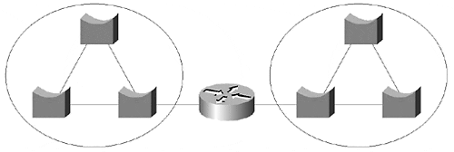
Each half in this network has a completely independent Spanning Tree. For example, each half elects a single Root Bridge. When a topology change occurs on the left side of the network, it has no effect on the right side of the network (at least from a Spanning Tree perspective). As Chapter 14, "Campus Design Models," discusses, you should strive to use Layer 3 routers and Layer 2 switches together to maximize the benefit that this sort of separation can have on the stability and scalability of your network.
On the other hand, routers do not always break a network into separate Spanning Trees. For example, there could be a backdoor connection that allows the bridged traffic to bypass the router as illustrated in Figure 7-8.

Figure 7-8 Although This Network Contains a Router, It Represents a Single Bridge Domain
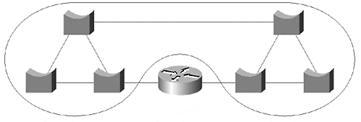
In this case, there is a single, contiguous, Layer 2 domain that is used to bypass the router. The network only elects a single Root Bridge, and topology changes can create network-wide disturbances.
Tip
By default, Route Switch Modules (RSMs) (and other router-on-a-stick implementations) do not partition the network as shown in Figure 7-7. This can significantly limit the scalability and stability of the network. See Chapter 11, "Layer 3 Switching," Chapter 14, "Campus Design Models," and Chapter 15, "Campus Design Implementation," for more information.

As Chapter 6 explained, Cisco uses a separate instance of Spanning Tree for each VLAN (per-VLAN Spanning Tree—PVST). This provides two main benefits: control and isolation.
Spanning Tree control is critical to network design. It allows each VLAN to have a completely independent STP configuration. For example, each VLAN can have the Root Bridge located in a different place. Cost and Priority values can be tuned on a per-VLAN basis. Per-VLAN control allows the network designer total flexibility when it comes to optimizing data flows within each VLAN. It also makes possible Spanning Tree load balancing, the subject of the next section.
Spanning Tree isolation is critical to the troubleshooting and day-to-day management of your network. It prevents Spanning Tree topology changes in one VLAN from disturbing other VLANs. If a single VLAN loses its Root Bridge, connectivity should not be interrupted in other VLANs.
Note
Although Spanning Tree processing is isolated between VLANs, don't forget that a loop in a single VLAN can saturate your trunk links and starve out resources in other VLANs. This can quickly lead to a death spiral that brings down the entire network. See Chapter 15 for more detail and specific recommendations for solving this nasty problem.

However, there are several technologies that negate the control and isolation benefits of PVST. First, standards-based 802.1Q specifies a single instance of Spanning Tree for all VLANs. Therefore, if you are using vanilla 802.1Q devices, you lose all of the advantages offered by PVST. To address this limitation, Cisco developed a feature called PVST+ that is discussed later in this chapter. Second, bridging between VLANs defeats the advantages of PVST by merging the multiple instances of Spanning Tree into a single tree.
Note
Although the initial version of 802.1Q only specified a single instance of the Spanning-Tree Protocol, future enhancements will likely add support for multiple instances. At presstime, this issue was being explored in the IEEE 802.1s committee.

To avoid the confusion introduced by these issues and exceptions, it is often useful to employ the term Spanning Tree domain. Each Spanning Tree domain contains its own set of STP calculations, parameters, and BPDUs. Each Spanning Tree domain elects a single Root Bridge and converges on one active topology. Topology changes in one domain do not effect other domains (other than the obvious case of shared equipment failures). The term Spanning Tree domain provides a consistent nomenclature that can be used to describe STP's behavior regardless of whether the network is using any particular technology.

Spanning Tree Load Balancing
The previous section discussed the concepts of PVST and how it allows Spanning Tree isolation and control. One of the most important benefits of this isolation and control is load balancing, the capability to utilize multiple active paths.
There is both good and bad news associated with load balancing. The good news is that it can be used to effectively double your network's throughput. The bad news is that it can triple the complexity to your network! Although I might be exaggerating a bit, the added complexity can be especially burdensome in a poorly designed network (see Chapters 14 and 15 for more information). This section takes a detailed look at the techniques that are available for implementing this advanced feature. By examining the theory behind each feature, you will be well equipped to maximize your available bandwidth with minimal added complexity.
It is important to realize that the term load balancing is a bit of a euphemism. In reality, Spanning Tree load balancing almost never achieves an even distribution of traffic across the available links. However, by allowing the use of more than one path, it can have a significant impact on your network's overall performance. Although some people prefer to use terms such as load distribution or load sharing, this text uses the more common term of load balancing.
There are four primary techniques for implementing Spanning Tree load balancing on Catalyst gear. Table 7-1 lists all four along with the primary command used to implement each.

Table 7-1. Techniques for Spanning Tree Load Balancing
Technique | Command
Root Bridge Placement | set spantree priority
Port Priority | set spantree portvlanpri
Bridge Priority | set spantree priority
Port Cost | set spantree portvlancost
Each of these is discussed in the separate sections that follow. Note that the discussion only addresses load balancing techniques based on the Spanning-Tree Protocol. For a discussion of non-STP load balancing techniques, see Chapter 11 and Chapter 15.

General Principles of Spanning Tree Load Balancing
Spanning Tree load balancing requires that two characteristics be built into the network:
- Multiple paths that form loops
- Multiple VLANs
If the network doesn't contain loops, there cannot be multiple paths over which the load can be distributed. By way of illustration, if two switches only have one Fast Ethernet link between them, it is fairly difficult to do any load balancing. This concept is obviously tightly coupled with the desire to have redundancy in campus networks. For example, most networks employ at least two links to every IDF wiring closet to meet reliability and availability requirements even if the bandwidth requirements are low. However, after the redundant paths are available, the question becomes, "How do you make use of them?" In fact, load balancing is all about having the best of both worlds—redundancy and speed.
However, if loops exist in the network, isn't Spanning Tree designed to remove them from the active topology? In other words, how can you use multiple paths if Spanning Tree prunes the network back to a single set of paths that reach from every location to every other location? Well, with only one Spanning Tree domain, you can't. On the other hand, VLANs make it possible to create multiple Spanning Tree domains over a single physical infrastructure. By intentionally designing different active topologies into each VLAN, you can utilize multiple redundant paths. Within a single VLAN, the traffic is loop free and only utilizes a single path to reach each destination. But two VLANs can use both redundant links that you have installed to a wiring closet switch.
For example, consider Figure 7-9, a variation of the simplified campus network used in Figure 7-2.

Figure 7-9 A Simplified Campus Network
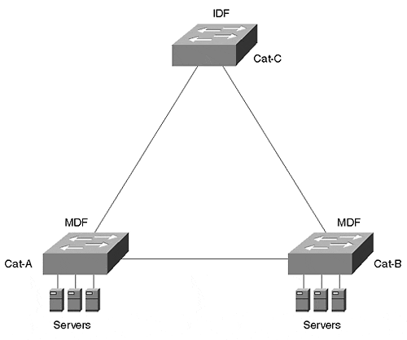
In this version of the simplified campus network, the campus backbone has been eliminated so that the entire network is contained within a single building. Instead of locating the server farm in a separate building, the servers have been moved to the MDF closets. Redundant links have been provided to the IDF switches (only one IDF is shown). Assume that the wiring closet switch only supports 20 users that rarely generate more than 100 Mbps of traffic. From a bandwidth perspective, a single riser link could easily handle the load. However, from a redundancy perspective, this creates a single point of failure that most organizations are not willing to accept. Given the assumption that corporate policy dictates multiple links to every wiring closet, wouldn't it be nice to have all the links available for carrying traffic? After all, after both links have been installed, Spanning Tree load balancing can potentially double the available bandwidth for free! Having three paths to every closet is indicative of two things: You work for a really paranoid organization and you can possibly triple your bandwidth for free!
Even when redundant links are available, don't overlook the second STP requirement for Spanning Tree load balancing—multiple VLANs. Many organizations prefer to place a single VLAN on each switch to ease VLAN administration. However, this is in conflict with the goal of maximizing bandwidth through load balancing. Just remember—one VLAN=one active path. This is not meant to suggest that it's wrong to place a single VLAN on a switch, just that it prevents you from implementing Spanning Tree load balancing.
Tip
If you only place a single VLAN on a switch, you cannot implement Spanning Tree load balancing. Either add VLANs or consider other load balancing techniques such as EtherChannel or MHSRP. See Chapter 11 and Chapter 15 for more information.

Root Bridge Placement Load Balancing
Fortunately, one of the most effective load balancing techniques is also the simplest. By carefully placing the Root Bridge for each VLAN in different locations, data can be forced to follow multiple paths. Each VLAN looks for the shortest path to its Root Bridge.
For example, Figure 7-10 adds load balancing to the network in Figure 7-9.

Figure 7-10 Load Balancing through Root Bridge Placement
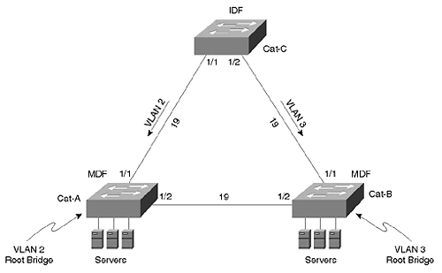
This network contains two VLANs. Cat-A is the Root Bridge for VLAN 2, and Cat-B is the Root Bridge for VLAN 3. From Cat-C's perspective, the available bandwidth to the servers has been doubled. First, examine VLAN 2. Cat-C has two possible paths to the Root Bridge: Cat-C:Port-1/1 can reach the Root Bridge with a cost of 19, whereas Cat-C:Port-1/2 can get there at a cost of 38. Obviously, Port 1/1 is chosen as Cat-C's Root Port for VLAN 2. VLAN 3 also has two paths to the Root Bridge, but this time the costs are reversed: 38 through Port 1/1 and 19 through Port 1/2. Therefore, VLAN 3's traffic uses Cat-C:Port-1/2. Both links are active and carrying traffic. However, if either link fails, Spanning Tree places all bandwidth on the remaining link to maintain connectivity throughout the network.

Root Bridge Placement in Hierarchical Networks
The advantage of Root Bridge placement load balancing is that it can provide a simple yet effective increase in the network's aggregate bandwidth. This is especially true with networks that utilize Layer 3 switching in designs such as the multilayer model discussed in Chapters 14 and 15. In this case, the Root Bridges should simply be co-located (or located near) the routers serving as the default gateways. For example, Figure 7-11 uses this approach to load balancing traffic for VLANs 2 and 3.

Figure 7-11 Co-locating Root Bridges with Default Gateways
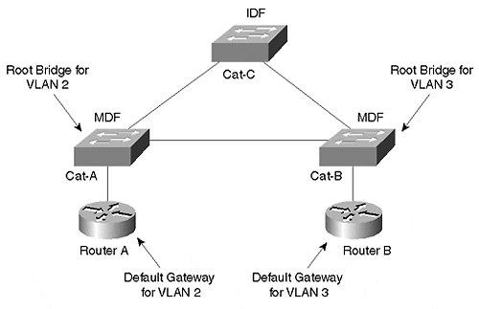
Not only has the load been distributed between the two routers (Router A is handling VLAN 2, whereas Router B is handling VLAN 3), the Layer 2 load has also been spread across both IDF uplinks. By placing the Root Bridge for VLAN 2 on Cat-A, the Spanning-Tree Protocol automatically creates the best Layer 2 path to the default gateway, the first-hop destination of most traffic in modern campus networks. The same has been done with Cat-B and VLAN 3.
More information on this technique (including how to use HSRP for redundancy) is discussed in Chapter 11.

Root Bridge Placement in Flat Networks
Although Root Bridge placement is appropriate for most well-designed campus networks such as that shown in Figure 7-11, the disadvantage is that many topologies do not support this approach. This is especially true of non-hierarchical, flat-earth networks. In some of these networks, traffic patterns are not clearly enough defined (or understood) for this technique to be effective. In other cases, the traffic between the VLANs is too similar.
As Chapter 15 discusses, the general rule of thumb in non-hierarchical networks is that you should try to place your Root Bridges in the path of your high-volume traffic flows. In the case of flat-earth networks, this usually translates into locating the Root Bridges as close to your servers as possible. Because end-station-to-server farm traffic accounts for over 90 percent of the load on most modern networks, this approach causes Spanning Tree to look for the shortest paths where your load is heaviest. If you place the Root Bridge at the other end of the network from your server farm, the high-volume traffic might be forced to take a very inefficient path.
Therefore, the Root Bridge placement load balancing technique is most effective in flat-earth networks where there is a clearly defined server location for every VLAN. Simply place the Root Bridge on the server farm switches and Spanning Tree naturally looks for the most efficient path. Figure 7-12 illustrates such a network.

Figure 7-12 Root Bridge Placement Load Balancing Requires Well-Defined Traffic Patterns
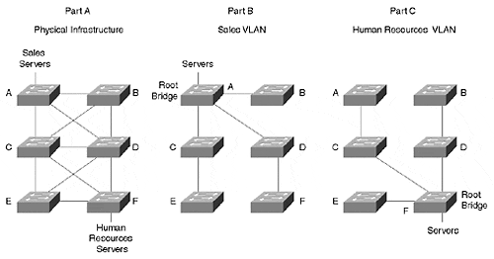
Part A of Figure 7-12 illustrates the physical topology and the location of servers. The Sales department has its servers attached to Cat-A, whereas the Human Resources department has connected their servers to Cat-F. Part B of Figure 7-12 shows the active topology for the Sales VLAN. By placing the Root Bridge at the servers, the Spanning Tree topology automatically mirrors the traffic flow. Part C of Figure 7-12 shows the active topology for the Human Resources VLAN. Again, the paths are optimal for traffic destined to the servers in that VLAN. Consider what happens if the Root Bridges for both VLANs are placed on Cat-F. This forces a large percentage of the Sales VLAN's traffic to take an inefficient path through Cat-F.
A potential problem with using this technique is that the traffic between the VLANs might be too similar. For example, what if a single server farm handles the entire network? You are left with two unappealing options. First, you could optimize the traffic flow by placing all of the Root Bridges at the server farm, but this eliminates all load balancing. Second, you could optimize for load balancing by distributing the Root Bridges, but this creates unnecessary bridge hops for traffic that is trying to reach the servers.

Implementing Root Bridge Placement
To implement Root Bridge placement load balancing, use the set spantree priority command discussed in the "Manual Root Bridge Placement: set spantree priority" section of Chapter 6. For instance, load balancing could be achieved in Figure 7-12 with the following commands:

Cat-A (enable) set spantree priority 100 2
Cat-F (enable) set spantree priority 100 3

The first command lowers the Bridge Priority on Cat-A to 100 for VLAN 2 (the Sales VLAN) so that it wins the Root Bridge election. In a similar fashion, the second command configures Cat-F to be the Root Bridge for VLAN 3 (the Human Resources VLAN).

Port/VLAN Priority Load Balancing
Another topology where Root Bridge placement load balancing does not work is with back-to-back switches or bridges. For example, consider Figure 7-13.

Figure 7-13 Back-to-Back Switches Cannot Use Root Bridge Placement Load Balancing
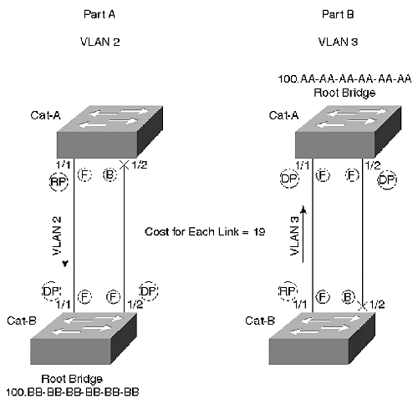
First, examine VLAN 2 as shown in Part A. Cat-A needs to pick a single Root Port to reach Cat-B, the Root Bridge for VLAN 2. As soon as Cat-A recognizes Cat-B as the Root Bridge, Cat-A begins evaluating Root Path Cost. Because both Cat-A:Port-1/1 and Cat-A:Port-1/2 have a cost of 19 to the Root Bridge, there is a tie. In an effort to break the tie, Cat-A considers the Sending BID that it is receiving over both links. However, both ports are connected to the same bridge, causing Cat-A to receive the same Sending BID (100.BB-BB-BB-BB-BB-BB) on both links. This results in another tie. Finally, Cat-A evaluates the Port ID values received in Configuration BPDUs on both ports. Cat-A:Port-1/1 is receiving a Port ID of 0x8001, and Cat-A:Port-1/2 is receiving a Port ID of 0x8002. Cat-A chooses the lower value for a Root Port, causing it to send all traffic out Port 1/1 while Blocking on Port 1/2.
With VLAN 3 in Part B of Figure 7-13, the roles are reversed but the outcome is the same—all traffic is passing over the left link. In this case, it is Cat-B that must elect a Root Port to reach the Root Bridge, Cat-A. Cat-B calculates identical values for Root Path Cost and Sending BID as discussed in the previous paragraph. To resolve the resulting tie, Cat-B evaluates the received Port ID values, chooses Port 1/1 as the Root Port, and places Port 1/2 in the Blocking state.
Although the Root Port selection and traffic flow is happening in the opposing direction, both switches have selected Port 1/1 as the Forwarding link. The result—the left link is carrying 100 percent of the traffic, and the right link is totally idle.
Note
Note that it is possible to implement load balancing in Figure 7-13 by crossing the cables such that Cat-B:Port-1/1 connects to Cat-A:Port-1/2 and Cat-B:Port-1/2 connects to Cat-A:Port-1/1. However, this approach is not very scalable and can be difficult to implement in large networks. Exercise 1 at the end of this chapter explores this load balancing technique.

Although the network in Figure 7-13 fails to implement load balancing, it does raise two interesting points. First, notice that it is the non-Root Bridge that must implement load balancing. Recall that all ports on the Root Bridge become Designated Ports and enter the Forwarding state. Therefore, it is the non-Root Bridge that must select a single Root Port and place the other port in a Blocking state. It is precisely this decision process that must be influenced to implement load balancing.
Second, it is the received values that are being used here. Cat-A is not evaluating its own BID and Port ID; it is looking at the values contained in the BPDUs being received from Cat-B.
Note
There is one case where the local Port ID is used. As shown in Figure 7-14, imagine two ports on Cat-B connecting to a hub that also connects to Cat-A, the Root Bridge. In this case, the received Port ID is the same on both ports of Cat-B. To resolve the tie, Cat-B needs to evaluate its own local Port ID values (the lower Port ID becomes the Root Port). This topology is obviously fairly rare in modern networks and not useful for load balancing purposes.

Figure 7-14 Using the Local Port ID Value As a Tie-Breaker
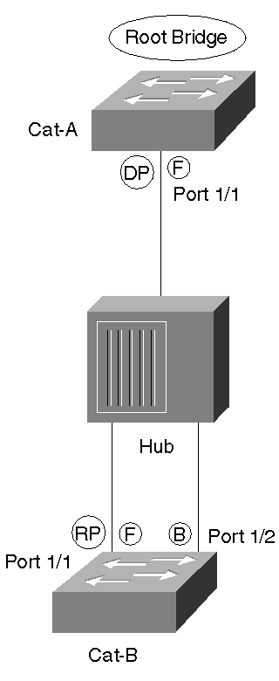

How can the load balancing be fixed in Figure 7-13? Given that Port ID is being used as decision criterion to determine which path to use, one strategy is to focus on influencing these Port ID values. On Catalysts using the XDI/CatOS interface (such as the Catalyst 4000s, 5000s, and 6000s), this can be done by applying the set spantree portvlanpri command. The full syntax for this command is

set spantree portvlanpri mod_num/port_num priority [vlans]

where mod_num is the slot number that a line card is using and port_num is the port on an individual line card.
As with the other set spantree and show spantree commands already discussed, the vlans parameter is optional. However, I suggest that you always code it so that you don't accidentally modify VLAN 1 (the default) one day.
The priority parameter can have the values ranging from 0 to 63, with 32 being the default. The priority parameter adjusts the Port ID field contained in every Configuration BPDU. Although the Port ID field is 16 bits in length, set spantree portvlanpri just modifies the high-order 6 bits of this field. In other words, Port ID consists of the two subfields shown in Figure 7-15.

Figure 7-15 Port ID Is a 16-Bit Field Consisting of Two Subfields
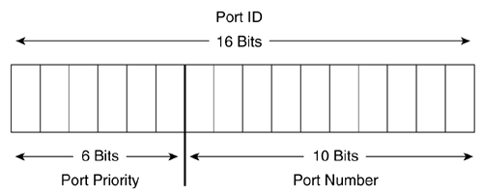
Port Number is a unique value statically assigned to every port: 1 for Port 1/1, 2 for Port 1/2, and so on (because number ranges are assigned to each slot, not all of the numbers are consecutive). Being 10 bits in length, the Port Number subfield can uniquely identify 2¹⁰, or 1,024, different ports. The high-order 6 bits of the Port ID field hold the Port Priority subfield. As a 6-bit number, this subfield can mathematically hold 2⁶=64 values (0 to 63, the same values that can be used with the set spantree portvlanpri command). Because the Port Priority subfield is contained in the high-order bits of Port ID, lowering this value by even one (to 31 from the default of 32) causes that port to be preferred.
The overly observant folks in the crowd might notice that Cisco routers use a different range of Port Priority values than do Catalyst switches. Whereas Catalysts accept Port Priority values between 0 and 63, the routers accept any value between 0 and 255. This difference comes from the fact that the routers are actually using the values specified in the 802.1D standard. Unfortunately, the 802.1D scheme only uses 8 bits for the Port Number field, limiting devices to 256 ports (2⁸). Although this is more than adequate for traditional routers, it is a significant issue for high-density switches such as the Catalyst 5500. By shifting the subfield boundary two bits, the Catalysts can accommodate the 1,024 ports calculated in the previous paragraph (2¹⁰). Best of all, this difference is totally harmless—as long as every port has a unique Port ID, the Spanning-Tree Protocol is perfectly happy. In fact, as combined Layer 2/Layer 3 devices continue to grow in popularity and port densities continue to increase, this sort of modification to the 802.1D specification should become more common.
Note
Starting in 12.0 IOS, the routers started using a subfield boundary that allows the Port Number subfield to be between 9 and 10 bits in length. This was done to support high-density bridging routers such as the 8540. The new scheme still allows Port Priority to be specified as an 8-bit value (0–255) and then the value is divided by either two (9-bit Port Number) or four (10-bit Port Number) to scale the value to the appropriate size.

How does all this bit-twiddling cause traffic to flow across multiple paths? Figure 7-16 redraws the VLANs originally presented in Figure 7-13 to locate the Root Bridge for both VLANs on Cat-B.

Figure 7-16 Back-to-Back Switches: The Root Bridge for Both VLANs Is on Cat-B
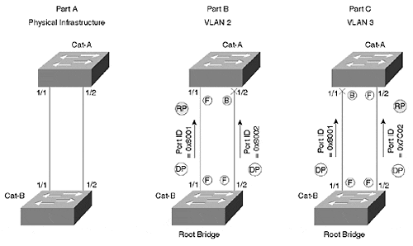
As was the case with Part A of Figure 7-13, the default Configuration BPDUs received on Port 1/1 of Cat-A contains a Port ID of 0x8001, but Port 1/2 receives the value 0x8002. Because 0x8001 is lower, Port 1/1 becames the Root Port for all VLANs by default. However, if you lower VLAN 3's Port Priority to 31 on Cat-B:Port-1/2, it lowers the Port ID that Cat-A:Port-1/2 receives for VLAN 3 to 0x7C01. Because 0x7C01 is less than 0x8001, Cat-A now elects Port 1/2 as the Root Port for VLAN 3 and sends traffic over this link. The syntax to implement this change is as follows:

Cat-B (enable) set spantree portvlanpri 1/2 31 3

Voilá, you have load balancing—VLAN 2 is using the left link and VLAN 3 is using the right link.
Tip
Note that the portvlanpri value must be less than the value specified by portpri.

By default, Cat-A is already sending traffic over the 1/1 link, so it is not necessary to add any commands to influence this behavior. However, it is probably a good idea to explicitly put in the command so that you can document your intentions and avoid surprises later:

Cat-B (enable) set spantree portvlanpri 1/1 31 2

This command lowers Cat-B's Port Priority on Port 1/1 to 31 for VLAN 2 and reinforces Cat-A's default behavior of sending traffic over this link for VLAN 2.

Precautions for Using Port/VLAN Priority Load Balancing
Notice that you must adjust the Port Priority on Cat-B to influence the load balancing on Cat-A. Adjusting the Port Priority on Cat-A has no effect as long as Cat-B is the Root Bridge. Recall that the Root Bridge is forwarding on all of its ports and therefore not making any load balancing decisions. This scheme of adjusting one switch's Port Priorities to influence another switch's load balancing is very counterintuitive. Just remember, to use port/VLAN priority load balancing, you must adjust the upstream bridge (the one closer to the Root Bridge, or, in this case, the Root Bridge itself).
Confusion can really set in when you take a look at the output of show spantree when using this form of load balancing. For example, Example 7-1 lists the output for VLAN 3 on Cat-A.

Example 7-1 show spantree Output for VLAN 3 on Cat-A
Cat-A (enable) show spantree 3 VLAN 3 Spanning tree enabled Spanning tree type ieee Designated Root 00-e0-f9-16-28-00 Designated Root Priority 100 Designated Root Cost 19 Designated Root Port 1/2 Root Max Age 20 sec Hello Time 2 sec Forward Delay 15 sec Bridge ID MAC ADDR 00-e0-f9-52-ba-00 Bridge ID Priority 32768 Bridge Max Age 20 sec Hello Time 2 sec Forward Delay 15 sec Port Vlan Port-State Cost Priority Fast-Start Group-method --------- ---- ------------- ----- -------- ---------- ------------ 1/1 1 blocking 19 32 disabled 1/2 1 forwarding 19 32 disabled
As you might expect on a device performing load balancing, one port is forwarding and one is blocking (see the last two lines from Example 7-1). You can also observe that the load balancing is having the desired effect because Port 1/2 is the forwarding port. However, notice how the Port Priority is still set at 32. At first this might appear to be a bug. On the contrary, the Port Priority field of show spantree only shows the outbound Port Priority. To see the values Cat-A is receiving, you must look at Cat-B's outbound values as shown in Example 7-2.

Example 7-2 show spantree Output for VLAN 3 on Cat-B
Cat-B (enable) show spantree 3 VLAN 3 Spanning tree enabled Spanning tree type ieee Designated Root 00-e0-f9-16-28-00 Designated Root Priority 100 Designated Root Cost 0 Designated Root Port 1/0 Root Max Age 20 sec Hello Time 2 sec Forward Delay 15 sec Bridge ID MAC ADDR 00-e0-f9-16-28-00 Bridge ID Priority 100 Bridge Max Age 20 sec Hello Time 2 sec Forward Delay 15 sec Port Vlan Port-State Cost Priority Fast-Start Group-method --------- ---- ------------- ----- -------- ---------- ------------ 1/1 1 forwarding 19 32 disabled 1/2 1 forwarding 19 31 disabled
There it is—Port 1/2's Priority has been set to 31. If you think about the theory behind using set spantree portvlanpri, this makes perfect sense. However, it's very easy to look for the value on Cat-A, the device actually doing the load balancing.
Tip
The received Port ID can be viewed on Cat-A with the show spantree statistics command. This feature is discussed in the "Useful STP Display Commands" section toward the end the chapter.

Keeping all of this straight is especially fun when you are trying to track down some network outage and the pressure is on! In fact, it is this counterintuitive nature of port/VLAN priority that makes it such a hassle to use.
As if the confusing nature of port/VLAN priority wasn't bad enough, set spantree portvlanpri canonly be used in back-to-back situations. Recall that Port ID is evaluated last in the STP decision sequence. Therefore, for it to have any effect on STP's path sections, both Root Path Cost and Sending BID must be identical. Although identical Root Path Costs are fairly common, identical Sending BIDs only occur in one topology: back-to-back bridges. For example, look back at Figure 7-3. Cat-D never receives the same Sending BID on both links because they are connected to completely different switches, Cat-B and Cat-C. Modifying port/VLAN priority in this case has no effect on load balancing.
Tip
Don't use set spantree portvlanpri in the typical model where each IDF switch is connected to redundant MDF switches; it does not work.

Although port/VLAN priority is useful in back-to-back configurations, I recommend that you never use it for that purpose. Why? Because Cisco's EtherChannel technology provides much better performance. Not only does it offer faster failover response, but it often results in better load balancing. EtherChannel is discussed in Chapter 8, "Trunking between Catalysts."
Tip
Don't use set spantree portvlanpri with back-to-back configurations. Instead, use Fast or Gigabit EtherChannel.

Unfortunately, many documents simply present set spantree portvlanpri as the way to do load balancing in a switched network. By failing to mention its limitations and proper use (for example, that it should be coded on the upstream bridge), many users are led on a frustrating journey and never get load balancing to work.
Given all the downsides, why would anyone use port/VLAN priority load balancing? In general, Root Bridge placement and port/VLAN cost provide a much more intuitive, flexible, and easy-to-understand options. However, there are two cases where set spantree portvlanpri might be useful. First, if you are running pre-3.1 NMP code, the port/VLAN cost feature is not available. Second, you might be using back-to-back switches in a configuration where Etherchannel is not an option—for example, if you are using non-EtherChannel capable line cards in your Catalyst or the device at the other end of the link is from another vendor (God forbid!).
Note
The version numbers given in this chapter are for Catalyst 5000 NMP images. Currently, this is the same numbering scheme that the Catalyst 4000s and 6000s use. Other Cisco products might use different numbering schemes.

Finally, don't confuse set spantree portvlanpri with the set spantree portpri command. The set spantree portpri command allows you to modify the high-order 6 bits of the Port ID field; however, it modifies these bits for all VLANs on a particular port. This obviously does not support the sort of per-VLAN load balancing being discussed in this section. On the other hand, set spantree portvlanpri allows Port Priority to be adjusted on a per-port and per-VLAN basis.
Note
To save NVRAM storage space, set spantree portvlanpri only allows you to set a total of two priority values for each port. One is the actual value specified on the set spantree portvlanpri command line. The other is controlled through the set spantree portpri command. This behavior can appear very strange to uninformed users. See the section "Load Balancing with Port/VLAN Cost" for more detail (port/VLAN cost also suffers from the same confusing limitation). However, this limitation rarely poses a problem in real-world networks (in general, it is only required for back-to-back switches linked by more than two links, a situation much better handled by EtherChannel).

Potential Issues in Real-World Networks
Before discussing the remaining two load balancing techniques, this section examines issues that arise when trying to load balance in more complex campus networks. In doing so, it demonstrates the potential ineffectiveness of Root Bridge placement and set spantree portvlanpri load balancing as covered in previous sections.
Although Root Bridge placement and set spantree portvlanpri can be effective tools in certain topologies, what if your network consists of two buildings that form a campus as illustrated in Figure 7-17?

Figure 7-17 A Campus Network where Root Bridge Placement and Port Priority Load Balancing Are Not Effective
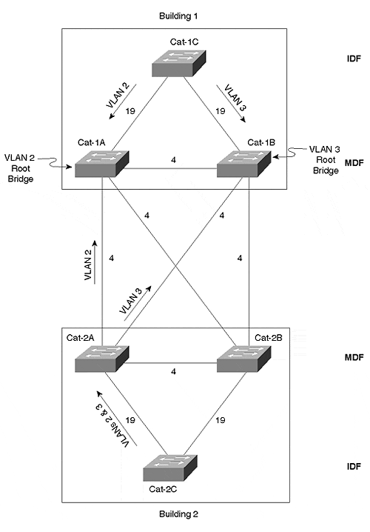
Figure 7-17 is a simplified diagram of a typical (but not necessarily recommended) campus design. In this design, VLANs 2 and 3 span all switches in both buildings. Each building consists of a pair of redundant MDF (Main Distribution Frame) switches in the main wiring closet. Both MDF switches connect to the IDF (Intermediate Distribution Frame) switches sitting on every floor (only one IDF switch in each building is shown to simplify the diagram). Link costs are also indicated (the IDF links are Fast Ethernet and MDF links are Gigabit Ethernet).
To implement load balancing, you cannot use the Port Priority load balancing technique because the switches are not back-to-back. How about using Root Bridge placement? To load balance in Building 1, you could place the Root Bridge for VLAN 2 on Cat-1A while placing the Root Bridge for VLAN 3 on Cat-1B. This causes VLAN 2's traffic to use the left riser link and VLAN 3's traffic to use the riser on the right. So far so good.
But what does this do to the traffic in Building 2? The IDF switch in Building 2 (Cat-2C) has several paths that it can use to reach the Root Bridge for VLAN 2 (Cat-1A). Which of these paths does it use? Well, refer back to the four-step STP decision criteria covered earlier. The first criterion evaluated is always the Root Bridge. Because everyone is in agreement that Cat-1A is the Root Bridge for VLAN 2, Cat-2C proceeds to the second criterion—Root Path Cost. One possibility is to follow the path Cat-2C to Cat-2B to Cat-2A to Cat-1A at a Root Path Cost of 27 (19+4+4). A better option is Cat-2C to Cat-2B to Cat-1A at a cost of 23 (19+4). However, path Cat-2C to Cat-2A to Cat-1A also has a Root Path Cost of 23 (19+4).
Because there are two paths tied for the lowest cost, Cat-2A proceeds to the third decision factor—Sending BID. Assume that both Cat-2A and Cat-2B are using the default Bridge Priority (32,768). Also assume that Cat-2A has a MAC address of AA-AA-AA-AA-AA-AA and Cat-2B has a MAC address of BB-BB-BB-BB-BB-BB. Because Cat-2A has the lower BID (32,768.AA-AA-AA-AA-AA-AA), all traffic for VLAN 2 uses the path Cat-2C to Cat-2A to Cat-1B.
OK, how about VLAN 3? Because all switches are in agreement that Cat-1B is the Root Bridge of VLAN 3, Root Path Cost is considered next. One option is to follow the path Cat-2C to Cat-2A to Cat-1A to Cat-1B at a cost of 27 (19+4+4). A better option is Cat-2C to Cat-2A to Cat-1B at a cost of 23 (19+4). However, again, there is an equal cost path along Cat-2C to Cat-2B to Cat-1B (cost =19+4=23). Cat-2C then evaluates the BIDs of Cat-2A and Cat-2B, choosing Cat-2A. VLAN 3 traffic therefore follows the path Cat-2C to Cat-2A to Cat-1B. This does provide load balancing across the campus core, but now both VLANs are using the same IDF riser cable. In other words, the load balancing in Building 1 destroyed the load balancing in Building 2.
Clearly, a new technique is required. Assuming that you want to maintain both VLANs across both buildings (I am using this assumption because it is a common design technique; however, in general, I recommend against it—see Chapter 14 for more details), there are two options:
- Bridge Priority
- Port/VLAN cost
Of these, port/VLAN cost is almost always the better option. However, because set spantree portvlancost was not available until 3.1 Catalyst images, the Bridge Priority technique is discussed first.

Bridge Priority Load Balancing
How can Bridge Priority be used to accomplish load balancing in the two-building campus illustrated in Figure 7-17? As discussed in the previous section, the IDF switch (Cat-2C) found multiple equal cost paths to the Root Bridge. This caused the third decision criterion, Bridge ID, to be evaluated. Because Cat-2A and Cat-2B were using the default Bridge ID values, Cat-2A had the lower BID for all VLANs (32,768.AA-AA-AA-AA-AA-AA versus 32,768.BB-BB-BB-BB-BB-BB). This is precisely what ruined the load balancing in Building 2.
Given this scenario, try lowering the BID on Cat-2B, but just for VLAN 3. For example, you could enter the following command on Cat-2B:

Cat-2B (enable) set spantree priority 1000 3

For consistency, you should also enter the following command on Cat-2A (although this command merely reinforces the default behavior, it helps document your intentions):

Cat-2A (enable) set spantree priority 1000 2

Figure 7-18 illustrates the resulting topology and traffic flows.

Figure 7-18 Load Balancingg Usin Bridge Priority
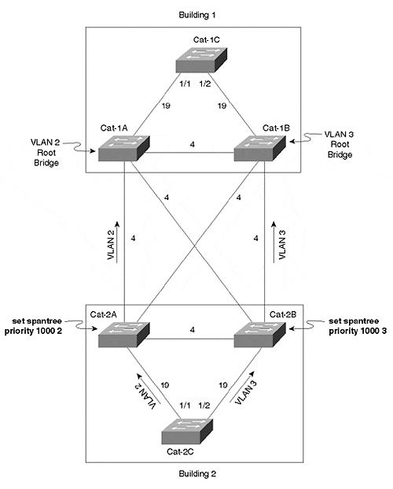
Note that these commands are adjusting Bridge Priority, not Port Priority. set spantree portvlanpri, the previous technique, was used to adjust Port Priority (the high-order 6 bits of the Port ID field) on a per-port and per-VLAN basis. On the contrary, Bridge Priority is a parameter that is global across all ports on a given switch, but it can be individually set for each VLAN on that switch.
"Wait a minute!" you exclaim. "Isn't this the same value I used to set the Root Bridge?" Yes, it is! The Bridge Priority must be low enough to influence the load balancing of traffic flows, but if it is too low, the bridge wins the Root War and disturbs the entire topology.
Picking the right balance of Port Priorities can be a tricky job in large, complex, and overly flat networks. In fact, it is one of the most significant problems associated with Bridge Priority load balancing. To maintain a consistent pattern, you should use a scheme such as 100, 200, 300,….to position your Root Bridges and 1000, 2000, 3000,…to influence load balancing. This numbering scheme helps you make your network self-documenting while also keeping the load balancing adjustments safely out of the range of the Root Bridge adjustments. This approach assumes that you don't have more than eight backup Root Bridges (if that's not the case, you probably have bigger problems than worrying about load balancing!).
Tip
Use a Bridge Priority numbering scheme that clearly delineates Root Bridge placement from load balancing. For example, use multiples of 100 for your Root Bridges and multiples of 1000 for load balancing.

An additional caveat of using Bridge Priorities to implement load balancing is that it can scale poorly. As your network grows, it is very difficult to keep track of which device has had its Bridge Priority adjusted for each VLAN for which reason (Root Bridge or load balancing).
Furthermore, the technique shares much of the confusion of set spantree portvlanpri. Namely, you must modify MDF switches to implement load balancing on IDF switches. Because it is the received BPDUs that are being evaluated on Cat-2C, changing the BID on Cat-2C has no effect. In short, you must modify the upstream switch when load balancing with either Bridge Priorities or port/VLAN priority.
To make matters even worse, this load balancing scheme creates an awkward situation where one technique is used in Building 1 (Root Bridge placement) and another technique is used in Building 2 (Bridge Priority). It is much more straightforward to use a simple technique that is flexible enough to implement load balancing in both buildings.
Why, then, does anyone choose to use Bridge Priorities to implement load balancing? For one simple reason—prior to 3.1 Catalyst 5000 code it was your only choice in certain topologies. However, don't get discouraged—starting in 3.1, Cisco offered a feature called port/VLAN cost load balancing that addresses these downsides.

Load Balancing with Port/VLAN Cost
Although Root Bridge placement is attractive because of its simplicity, port/VLAN cost load balancing can be very useful because of its flexibility. By virtue of this versatility, Port/VLAN cost can be an intuitive and effective load balancing scheme for almost every topology.
The port/VLAN priority and Bridge Priority load balancing sections looked at techniques for influencing STP when the costs were equal. The strategy behind port/VLAN cost is based on a very simple and sensible observation: if Root Path Cost is the second STP decision criterion, why are the third and fourth decision criteria being used to implement load balancing? In other words, why not just modify the cost directly?
Catalysts have always supported the set spantree portcost command. However, this command is not useful as a primary technique for load balancing because it changes the cost foreveryVLAN on a given port. It wasn't until 3.1 Catalyst 5000 code (all Catalyst 4000s and 6000s support it) that Cisco added set spantree portvlancost, a command that allows you to tune cost on both a per-port and per-VLAN basis.
Note
Somewhat ironically, the Catalyst 3000s (3000, 3100, and 3200) supported per-port and per-VLAN cost configuration well before the feature was moved into the high-end products such as the Catalyst 5000.

Increasing Path Cost for Load Balancing
Figure 7-19 illustrates how set spantree portvlancost can be used to implement STP load balancing. For simplicity, this example uses Cat-1A as the Root Bridge for all VLANs.

Figure 7-19 Load Balancing Using the set spantree portvlancost Command
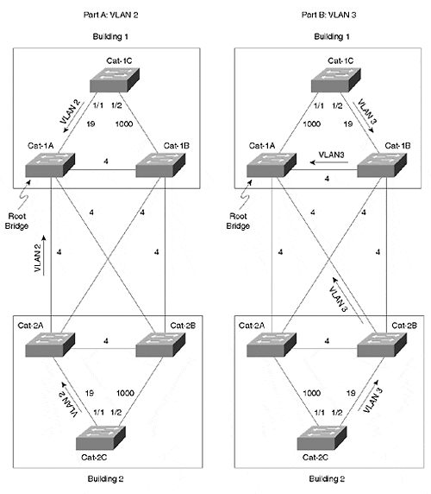
First, consider load balancing in Building 1. Cat-1C, the IDF switch in Building 1, has two potential paths to the Root Bridge. It can go directly to Cat-1A over the 1/1 link at a cost of 19, or it can use the 1/2 link to go through Cat-1B at a cost of 23 (19+4). The 1/1 link is fine for VLAN 2, but load balancing requires that VLAN 3 use the 1/2 link. This can be accomplished by increasing the Root Path Cost on the 1/1 link to anything greater than 23 for VLANs that should take the 1/2 link. For example, enter the command from Example 7-3 on Cat-1C to increase the Root Path Cost for VLAN 3 on Port 1/1 to 1000.

Example 7-3 Increasing the Cost for VLAN 3 on Cat-1C:Port-1/1
Cat-1C (enable) set spantree portvlancost 1/1 cost 1000 3 Port 1/1 VLANs 1-2,4-1005 have path cost 19. Port 1/1 VLANs 3 have path cost 1000.
Although a comparable entry is not required for VLAN 2 on the 1/2 link, it is generally a good idea to add it for consistency as illustrated in Example 7-4.

Example 7-4 Increasing the Cost for VLAN 2 on Cat-1C:Port-1/2
Cat-1C (enable) set spantree portvlancost 1/2 cost 1000 2 Port 1/2 VLANs 1,3-1005 have path cost 19. Port 1/2 VLANs 2 have path cost 1000.
The previous two commands increase the Root Path Cost on the undesirable link high enough to force traffic across the other IDF-to-MDF link. For example, the command in Example 7-3 discourages VLAN 3's traffic from using the 1/1 link, causing it to use the 1/2 link. However, if either riser link fails, all of the traffic rolls over to the remaining connection.
As mentioned earlier, it is important to understand the difference between Root Path Cost and Path Cost. This point is especially true when working with port/VLAN cost load balancing. Root Path Cost is the cumulative Spanning Tree cost from a bridge or switch to the Root Bridge. Path Cost is the amount that is added to Root Path Cost as BPDUs are received on a port. Notice that set spantree portvlancost is manipulating Path Cost, not Root Path Cost. It might help if you remember the command as set spantree portvlan pathcost (just don't try typing that in!).

Decreasing Path Cost for Load Balancing
An alternate approach is to decrease the cost on the desirable link. In fact, this is actually the manner in which the set spantree portvlancost command syntax was designed to support. Here is the full syntax of the set spantree portvlancost command:

set spantree portvlancost mod_num/port_num [cost cost_value] [preferred_vlans]

Notice that the set spantree portvlancost command allows you to omit several of the parameters as a shortcut. If you omit the cost parameter, it lowers the cost by one from its current value. If you omit the preferred_vlans parameter, it uses the VLAN list from the last time the command was used. In other words, the command in Example 7-5 is designed to make Port 1/2 the preferred path for VLAN 3.

Example 7-5 Selecting Cat-1C:Port-1/2 As the Preferred Path for VLAN 3 Using the Automatically Calculated Value
Cat-1C> (enable) set spantree portvlancost 1/2 3 Port 1/2 VLANs 1-2,4-1005 have path cost 19. Port 1/2 VLANs 3 have path cost 18.
Tip
Unlike most Spanning Tree commands on Catalysts that substitute the default value of 1 when the vlan parameter is omitted, set spantreee portvlancost uses the same VLAN (or VLANs) as the previous use of this command. To avoid surprises, it is safer to always specify both the cost and the preferred_vlansparameters.

However, lowering the cost to 18 on Port 1/2 for VLAN 3 does not work in situations such as Cat-1C in Figure 7-19. In this case, Cat-1C sees two paths to the Root Bridge. As explained earlier, the Root Path Cost values before tuning are 19 on the 1/1 link and 23 (19+4) on the 1/2 link. Lowering the 1/2 Path Cost by one results in a Root Path Cost for Port 1/2 of 22, not enough to win the Root Port election.
One solution is to manually specify a cost parameter that is low enough to do the trick as in Example 7-6.

Example 7-6 Selecting Cat-1C:Port-1/2 As the Preferred Path for VLAN 3 By Manually Specifying a Lower Cost on Port 1/2
Console> (enable) set spantree portvlancost 1/2 cost 14 3 Port 1/2 VLANs 1-2,4-1005 have path cost 19. Port 1/2 VLANs 3 have path cost 14.
This lowers the cumulative Root Path Cost on Port 1/2 to 18 (14+4) and causes it to win out against the cost of 19 on Port 1/1.
However, this approach might not be stable in the long run. What if the link between Cat-1A and Cat-1B is replaced with Fast Ethernet or Fast EtherChannel? Or what if an additional switch is added in the middle of this link? In fact, if anything is done to increase the cost between Cat-1A and Cat-1B, this load balancing scheme fails. Therefore, as a general rule of thumb, it is better to increase the cost of undesirable paths than decrease the cost of desirable paths.
Tip
Increasing the cost of undesirable paths is more flexible and scalable than decreasing the cost of desirable paths.

Advantages of Port/VLAN Cost Load Balancing
Getting back to the example in Figure 7-19, now consider the load balancing for Building 2. First, force STP to use the Cat-2C:Port-1/2 link for VLAN 3 by entering the commands in Example 7-7 and 7-8 on Cat-2C.

Example 7-7 Selecting Cat-2C:Port-1/2 As the Preferred Path for VLAN 3 By Manually Specifying a Higher Cost on Port 1/1
Cat-2C (enable) set spantree portvlancost 1/1 cost 1000 3 Port 1/1 VLANs 1-2,4-1005 have path cost 19. Port 1/1 VLANs 3 have path cost 1000.
Then, force VLAN 2 over the 1/1 link, as shown in Example 7-8.

Example 7-8 Selecting Cat-2C:Port-1/1 As the Preferred Path for VLAN 2
Cat-2C (enable) set spantree portvlancost 1/2 cost 1000 2 Port 1/2 VLANs 1,3-1005 have path cost 19. Port 1/2 VLANs 2 have path cost 1000.
See how much easier set spantree portvlancost is to use than the port/VLAN priority and Bridge Priority load balancing? First, it is much easier to visualize the impact that the commands are having on the network. Second, both IDF switches use similar and consistent commands. Third, and best of all, the commands are entered on the very switch where the load balancing is occurring—the IDF switch. If you have an IDF switch with multiple uplinks, just Telnet to that device and use set spantree portvlancost to spread the load over all available links. With port/VLAN cost, there is no need to make strange modifications to upstream switches.
The results of using set spantree portvlancost are also much easier to read in show spantree. For example, the output in Example 7-9 would appear for VLAN 2 on Cat-2C, the IDF switch in Building 2.

Example 7-9 show spantree Output for VLAN 2 After Using Port/VLAN Cost Load Balancing
Cat-2C (enable) show spantree 2 VLAN 2 Spanning tree enabled Spanning tree type ieee Designated Root 00-e0-f9-16-28-00 Designated Root Priority 100 Designated Root Cost 23 Designated Root Port 1/1 Root Max Age 20 sec Hello Time 2 sec Forward Delay 15 sec Bridge ID MAC ADDR 00-e0-f9-F2-44-00 Bridge ID Priority 32768 Bridge Max Age 20 sec Hello Time 2 sec Forward Delay 15 sec Port Vlan Port-State Cost Priority Fast-Start Group-method --------- ---- ------------- ----- -------- ---------- ------------ 1/1 1 forwarding 19 32 disabled 1/2 1 blocking 1000 32 disabled
The increased cost on the 1/2 link is plainly shown along with the fact that Port 1/1 is in the Forwarding state. Also notice that Port 1/1 is acting as the Root Port.
The output in Example 7-10 shows the Spanning Tree information for VLAN 3 on the same switch.

Example 7-10 show spantree Output for VLAN 3 After Using Port/VLAN Cost Load Balancing
Cat-2C (enable) show spantree 3 VLAN 3 Spanning tree enabled Spanning tree type ieee Designated Root 00-e0-f9-16-28-00 Designated Root Priority 100 Designated Root Cost 23 Designated Root Port 1/2 Root Max Age 20 sec Hello Time 2 sec Forward Delay 15 sec Bridge ID MAC ADDR 00-e0-f9-F2-44-00 Bridge ID Priority 32768 Bridge Max Age 20 sec Hello Time 2 sec Forward Delay 15 sec Port Vlan Port-State Cost Priority Fast-Start Group-method --------- ---- ------------- ----- -------- ---------- ------------ 1/1 1 blocking 1000 32 disabled 1/2 1 forwarding 19 32 disabled
In the case of Example 7-10, the 1/1 port is Blocking, whereas the 1/2 port is Forwarding. The Root Port has also shifted to 1/2 with a Root Path Cost of 23 (19 for the riser link plus 4 to cross the Gigabit Ethernet link between Cat-2B and Cat-1A).
Tip
Carefully observe the difference between Root Path Cost and Path Cost. Root Path Cost is the cumulative cost to the Root Bridge. Path Cost is the amount that each port contributes to Root Path Cost.

Because it is both flexible and easy to understand, port/VLAN cost is one of the most useful STP load balancing tools (along with Root Bridge placement). The only requirement is that you run 3.1 or higher code on the switches where you want to implement the load balancing (generally your IDF switches). Note that you do not need to run 3.1+ code everywhere, it is only necessary on the actual devices where set spantree portvlancostload balancing is configured (modifying the set spantree portvlancost on some devices does not create any interoperability problems with your other switches).

Precautions for Using Port/VLAN Cost Load Balancing
However, there is one potentially confusing matter that you should keep in mind when using set spantree portvlancost: each port is only allowed two Port Cost values (very similar to how each port is only allowed two port/VLAN priority values). The first value is the default cost for the port. This value is derived from the bandwidth chart presented in Table 6-1 of Chapter 6 and can be modified with the set spantree portcost command (it modifies cost for every VLAN on a port). The second value is the one configured with set spantree portvlancost. However, only a single set spantree portvlancost value can exist on a given port. If you configure multiple set spantree portvlancost values on a single port, all of the VLANs ever configured with set spantree portvlancost adopt the most recent value.
Tip
As with port/VLAN priority, the per-VLAN value must be less than the per-port value. In other words, the set spantree portvlancost value must be less than the set spantree portcost value.

For example, the command in Example 7-11 increases the cost to 1000 for VLANs 2 and 3 on Port 1/1.

Example 7-11 Increasing Port/VLAN Cost on Port 1/1 for VLANs 2 and 3
Cat-A> (enable) set spantree portvlancost 1/1 cost 1000 2-3 Port 1/1 VLANs 1,4-1005 have path cost 19. Port 1/1 VLANs 2-3 have path cost 1000.
Next, try increasing the Path Cost for VLAN 5 to 2000 as in Example 7-12.

Example 7-12 Trying to Specify a Different Port/VLAN Cost Value
Console> (enable) set spantree portvlancost 1/1 cost 2000 5 Port 1/1 VLANs 1,4,6-1005 have path cost 19. Port 1/1 VLANs 2-3,5 have path cost 2000.
Notice how it also changes the Path Cost for VLANs 2 and 3. A quick look at the output of show spantree in Example 7-13 confirms the change.

Example 7-13 Only the Most Recently Specified Port/VLAN Cost Value Is Used
Console> (enable) show spantree 1/1 Port Vlan Port-State Cost Priority Fast-Start Group-Method --------- ---- ------------- ----- -------- ---------- ------------ 1/1 1 forwarding 19 31 disabled 1/1 2 forwarding 2000 31 disabled 1/1 3 forwarding 2000 31 disabled 1/1 4 forwarding 19 31 disabled 1/1 5 forwarding 2000 31 disabled 1/1 6 forwarding 19 31 disabled 1/1 7 forwarding 19 31 disabled 1/1 8 forwarding 19 31 disabled 1/1 9 forwarding 19 31 disabled 1/1 10 forwarding 19 31 disabled
Poof! The cost of 1000 is gone. As mentioned in the "Port/VLAN Priority Load Balancing" section that covered the set spantree portvlanpri command (which also exhibits the behavior seen in Example 7-13), this sleight of hand is a subtle side effect caused by a technique the Catalysts use to save NVRAM storage. Internally, Catalysts store three different values related to cost per port:
- A global cost for that port
- A single set spantree portvlancost value
- A list of VLANs using the set spantree portvlancost value
Therefore, separate cost values cannot be stored for every VLAN. However, the good news is that, apart from its strange appearances, this is not a significant drawback in most situations. Networks with lots of redundancy and multiple links might find it a limitation, but most never notice it at all.

Spanning Tree Load Balancing Summary
In review, there are four techniques available for Spanning Tree load balancing on Catalyst equipment:
- Root Bridge Placement—
Traffic flows can be influenced by carefully locating Root Bridges throughout your network. This option is extremely viable and useful for organizations utilizing the multilayer design model discussed in Chapter 14. However, for networks employing less hierarchical designs, it can be hopeless.
- Port/VLAN Priority—
set spantree portvlanpri can be used to load balance between back-to-back switches. This technique allows network administrators to modify Port ID values on upstream switches to influence forwarding and blocking decisions on neighboring downstream switches. For a variety of reasons, the option is rarely useful.
- Bridge Priority—
Bridge Priorities can be used. In general, this technique is only useful in older software images (pre-3.1) where set spantree portvlancost is not available. As with set spantree portvlanpri, it requires that load balancing parameters be entered on the switch that is upstream of the switch actually performing the load balancing.
- Port/VLAN Cost—
set spantree portvlancost can be utilized. This technique is the most flexible option available for STP load balancing. In flat networks, it is also the simplest to implement. The only requirement is that you use 3.1 or later code on your devices. It allows the command to be entered and observed on the actual switch where the load balancing is being performed.
In short, Spanning Tree load balancing almost always boils down to one of two options. First, when using the MLS form of Layer 3 switching to build networks according to the multilayer design model (see Chapters 11 and 14), the Root Bridge Placement form of load balancing is generally most appropriate. Second, port/VLAN cost load balancing should be used in almost all other situations.

Fast STP Convergence
When discussing the five STP states, Chapter 6 mentioned that Spanning Tree starts ports in a Blocking state. Over a period of 30 to 50 seconds, ports work their way through the Listening and Learning states to finally reach the Forwarding state where user data is actually passed. Spanning Tree was intentionally designed with this conservative logic. Consider the alternative: if STP immediately brought ports into the Forwarding state, loops could form and prevent STP from ever getting any BPDUs through! Instead, STP keeps all ports from forwarding anything but BPDUs for at least 30 seconds by default. This is designed to give the bridges in almost all networks plenty of time to learn the physical topology and then create a loop-free logical topology.
However, the downside to this conservative behavior is slow convergence time. In a world that has grown accustomed to sub-ten-second-failover protocols such as Open Shortest Path First (OSPF), Enhanced IGRP (EIGRP), and Hot Standby Routing Protocol (HSRP), Spanning Tree's default behavior can be intolerably sluggish. In response to this need for speed, there are a variety of techniques available on Catalyst switches to improve on Spanning Tree's default performance. Some of these techniques merely implement features originally designed into the 802.1D protocol. Others take advantage of new and patented features researched and implemented by Cisco. These capabilities can play an important role in building large and stable switched backbones.
In total, Catalysts offer seven techniques to improve Spanning Tree's convergence time:
- Tuning Max Age
- Tuning Forward Delay
- Lowering Hello Time
- PortFast
- UplinkFast
- BackboneFast
- Disabling PAgP on EtherChannel-capable ports

Tuning Max Age
Recall that Spanning Tree centers around a process of each port saving a copy of the best BPDU it has heard. However, there must be some process to age out this stored information, otherwise, the network would never repair itself after the failure of a bridge or link. The Max Age timer controls the length of this age out period.
The Root Bridge generates Configuration BPDUs on all of its ports every 2 seconds (the default Hello Time interval). This triggers a cascade of Configuration BPDUs that, under normal conditions, should reach every segment in the network. As long as a non-Designated Port continues to receive Configuration BPDUs from the segment's Designated Port, the port's saved information never ages out. In other words, this continual refresh of more attractive BPDU information keeps the non-Designated Port in a Blocking state.
However, if an upstream bridge or link fails, the flow of Configuration BPDUs is interrupted. After Max Age seconds, the port starts sending its own Configuration BPDUs as it transitions into the Listening state. As long as no more attractive BPDUs are heard from other devices, the port eventually transitions through the Learning state and ends up in the Forwarding state. At this point, the port has restored connectivity to the local segment.
In practice, Max Age is used to detect indirect failures. For example, the directly connected failure illustrated in Figure 7-20 does not require Cat-C to use the Max Age timer.

Figure 7-20 Direct Failures Take Approximately 30 Seconds to Reconverge
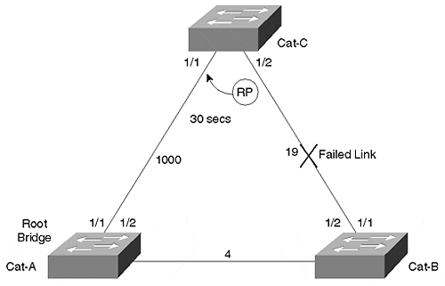
In this network, Cat-A is the Root Bridge, and Cat-C (an IDF switch) has selected Port 1/2 as its Root Port because it has a lower Root Path Cost (23 versus 1000). Assume that the cable connecting Cat-C and Cat-B fails. This produces an immediate physical layer loss of link on Cat-C:Port-1/2 and causes that port to be placed in the not-connected state. Port 1/2 is then immediately excluded from STP processing and causes Cat-C to start searching for a new Root Port. 30 seconds later (twice the Forward Delay), Port 1/1 enters the Forwarding state and connectivity resumes.
Tip
Max Age is used to detect and recover from indirect failures.

On the other hand, Figure 7-21 depicts an indirect failure.

Figure 7-21 Indirect Failures Take Approximately 50 Seconds to Reconverge
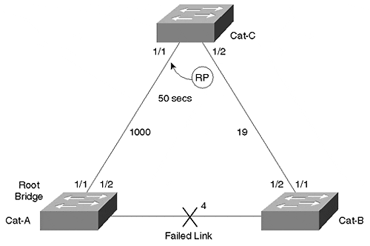
In this case, the link between Cat-A and Cat-B fails. Cat-C:Port-1/2 receives no direct notification that anything has changed. All Cat-C notices is that Configuration BPDUs stop arriving on Port 1/2. After waiting for the number of seconds specified by the Max Age timer, Cat-C:Port-1/1 starts to take over as the Root Port. This reconvergence takes considerably longer: 50 seconds as opposed to 30 seconds.
The default Max Age value of 20 seconds is designed to take two factors into account:
- End-to-End BPDU Propagation Delay
- Message Age Overestimate

Calculating End-to-End BPDU Propagation Delay for Max Age
End-to-End BPDU Propagation Delay is the amount of time that it takes for a BPDU to travel from one edge of the network to the other edge of the network. The 802.1D specification assumes that up to three BPDUs can get lost along the way, the maximum distance between any two nodes in the network is seven bridge hops, and each bridge can take up to one second to propagate a BPDU after receiving it. Also, the default Hello Time interval of two seconds is assumed. Table 7-2 documents these assumptions.

Table 7-2. Assumptions Used to Calculate the Default Max Age
Parameter | Value | Tunable | Description
lost_msgs | 3 | N | Lost Messages: Number of BPDUs that can be lost as a message moves from one end of the bridged network to the other. Reasons for the potential loss of BPDUs include issues such as congestion, CRC errors, physical layer issues, and software deficiencies (that is, bugs).
dia | 7 hops | Y | Diameter: The maximum number of bridge hops between any two end-station nodes in the network.
bpdu_delay | 1 sec | N | BPDU Transmission Delay: The maximum time a single bridge takes to propagate a BPDU after receiving it on another port.
hello_t | 2 secs | Y | Hello Time: The time between Configuration BPDUs that are originated on the Root Bridge.
These values can be used to calculate the End-to-End BPDU Propagation Delay using the following formula:

end-to-end_bpdu_propagation_delay
= ((lost_msgs + 1) × hello_t) + (bpdu_delay × (dia– 1))
= ((3 + 1) × 2) + (1 × (7 – 1))
= 8 + 6 = 14 seconds

Calculating Message Age Overestimate for Max Age
The other component of Max Age is something referred to as Message Age Overestimate. This is the amount of time that the Message Age field carried in BPDUs can be overstated. Recall from the earlier section "STP Timers" that Message Age is the amount of time that has passed since the Root Bridge first originated the information the current BPDU is based on.
Although the 802.1D specification forbids a bridge from underestimating the Message Age field, it can become overstated because many bridges have limited timer resolution and just add a second at every hop. As a result, each bridge hop generally increases the amount of this overstatement, causing downstream bridges to potentially expire the Max Age counter too soon. 802.1D assumes that each bridge can contribute one second of Message Age Overstatement. Therefore, the total Message Age Overestimate can be calculated as follows:

message_age_overestimate
= (dia– 1) × overestimate_per_bridge
= (7 – 1) × 1
= 6 seconds

Tip
Note that this process of simply incrementing the Message Age field in each bridge causes bridges farther from the Root Bridge to age out their Max Age counters first. Therefore, this effect is more pronounced in flat-earth networks that consist of many Layer 2 switches connected without any intervening routers or Layer 3 switches. This is another advantage to creating hierarchy with Layer 3 switching as prescribed by the multilayer model in Chapter 14.

Calculating and Using Max Age
Max Age is simply the sum of these two previously calculated values:

Max Age = end-to-end_bpdu_propagation_delay + message_age_overestimate
= 14 + 6 = 20 seconds

Of the values assumed in this calculation, two are something you can consider tunable:
- Diameter
- Hello Time
If your bridged network diameter is considerably smaller than seven hops or your Hello Time has been set to one second, you might want to recalculate a new Max Age value. The result can then be entered at your Root Bridges using the following command:

set spantree maxage agingtime [vlan]

Tip
When using Layer 3 switching to limit the size of your Spanning Tree domains, the Max Age timer can be safely tuned. The extent of tuning that is possible is based on the style of Layer 3 switching in use and the overall campus network design. See Chapter 15 for specific details and recommendations.
You can only modify the timer values on Root Bridges. Don't forget to also change the values on any backup Root Bridges.

If you do lower the Hello Time interval, carefully consider the impact that it has on your CPU. STP can easily be the single most intensive CPU process running on a modern bridge (which does all of the frame forwarding in hardware). Cutting the Hello Time interval in half doubles the load that STP places on your CPU. See the sections "Lowering Hello Time to One Second" and "Tips and Tricks: Mastering STP" later in this chapter for more guidance.
Tip
Decreasing Hello Time to one second doubles the STP load placed on your CPU. Use the formula presented at the end of the chapter to be certain that this does not overload your CPU. However, in networks that contain a limited numbers of VLANs, lowering Hello Time to one second can be an excellent way to improve convergence times. See the section "Lowering Hello Time to One Second" for more information.

Precautions for Tuning Max Age
If you assume a lower network diameter, be careful to look for unexpected bridge hops that can crop up during failure conditions. Also, diameter is defined as the largest number of bridge hops between any two end-station nodes in your network. It is not just the number of hops between your primary Root Bridge and the farthest leaf node.
Tip
Be careful when calculating bridge diameter—unexpected hops can creep in when other links or devices fail.

Some of the 802.1D values might appear overly conservative. For instance, most users would argue that their networks would never drop three BPDUs while transferring information a mere seven bridge hops. Likewise, the assumption that each bridge takes one second to propagate a BPDU seems strange in a world of high-horsepower switching. Although it might be tempting to recalculate the formula with more "real-world" values, I strongly recommend against this. Keep in mind that these values were chosen to provide adequate margin in networks experiencing failure conditions, not just networks happily humming along while everything is operating at peak efficiency. When a failure does occur, your bandwidth and CPU capacity can be depleted as the network tries to recover. Be sure to leave some reserves to handle these situations.
Tip
Only modify the diameter and Hello Time variables in the Max Age calculation. Modifying the other values can surprise you some day (when you least expect it!).

Although any form of STP timer tuning can be dangerous, reducing Max Age can be less risky than other forms. If you set Max Age too low, a brief interruption in the flow of Configuration BPDUs in the network can cause Blocking ports to age out their BPDU information. When this happens, this rogue bridge starts sending Configuration BPDUs in an attempt to move into the Forwarding state. If there is a functioning Designated Port available for that segment, it refutes the BPDU with a Configuration BPDU of its own (this is the exception processing discussed earlier in the "Configuration BPDU Processing" section). However, if the Designated Port has failed, no device will refute the BPDU, and the rogue bridge might form a bridging loop before it hears from any neighboring bridges.
Tip
Modifying Max Age is less dangerous than changing the other timer values. Unfortunately, it only improves convergence in the case of an indirect failure.

Tuning Forward Delay
Forward Delay can add an agonizing amount of delay to the recovery time experienced in your network. Unlike Max Age, where direct failures cause that stage to be bypassed, all failures must wait through the Forward Delay stage twice (Listening and then Learning).
Given this sluggishness, it can be very tempting to try improving STP's performance by lowering the Forward Delay timer. However, unless this is done with considerable planning and care, it can have a devastating impact on your network. This section explores the thought process behind Forward Delay's default value and explores reasonable guidelines for tuning this parameter.
Forward Delay is used to control the migration of a port from the Blocking state to the Forwarding state. If this was an instantaneous transition, a loop could easily form and the network would collapse under the resulting load. Instead, bridges wait for twice the Forward Delay to allow BPDUs to propagate across the network and all traffic on the old topology to die. In addition, it must allow time for the same overestimate error in Message Age seen in the previous section.
To accommodate these three items, the default Forward Delay value recommended in the 802.1D specification accounts for the following four components that affect STP reconvergence:
- End-to-End BPDU Propagation Delay
- Message Age Overestimate
- Maximum Transmission Halt Delay
- Maximum Frame Lifetime
You might recognize the first two factors affecting convergence as being the same two used to calculate Max Age. These values represent the same two factors here: the time that it takes for BPDUs to move across the network and nodes expiring information too early because of an overstatement in the Message Age field. Conversely, the combination of the last two items allows time for information to age out of the old topology before the new topology takes effect.
The Forward Delay calculation uses the values shown in Table 7-3.

Table 7-3. Assumptions Used to Calculate the Default Forward Delay
Parameter | Value | Tunable | Description
lost_msgs | 3 | N | Lost Messages: Number of BPDUs that could get lost as a message moves from one end of the bridged network to the other.
dia | 7 hops | Y | Diameter: The maximum number of bridge hops between any two nodes in the network.
bpdu_delay | 1 sec | N | BPDU Transmission Delay: The maximum time a single bridge takes to propagate a BPDU after receiving it on another port.
hello_t | 2 secs | Y | Hello Time: The time between Configuration BPDUs that are originated on the Root Bridge.
tx_halt_delay | 1 sec | N | Transmit Halt Delay: The time it takes for a bridge to stop sending traffic on a port after it enters the Blocking state.
transit_delay | 1 sec | N | Bridge Transit Delay: The time it takes for a bridge to propagate a data frame.
med_access_delay | .5 sec | N | Maximum Medium Access Delay: The time it takes for a device to gain access to the wire to initially transmit a frame.

Calculating End-to-End BPDU Propagation Delay and Message Age Overestimate for Forward Delay
These components are used to calculate Forward Delay as follows:

end-to-end_bpdu_propagation_delay
= ((lost_msgs+ 1) × hello_t) + (bpdu_delay× (dia– 1))
= ((3 + 1) × 2) + (1 × (7 – 1))
= 8 + 6 = 14 seconds
message_age_overestimate
= (dia– 1) × overestimate_per_bridge
= (7 – 1) × 1
= 6 seconds

These two calculations are the same two used to derive Max Age. With Forward Delay, just as in Max Age, they account for the time it takes to propagate BPDUs across the network and for the error present in the Message Age field of Configuration BPDUs.

Calculating Maximum Transmission Halt Delay
Maximum Transmission Halt Delay is designed to account for the lag that can occur before a bridge puts a port into the Blocking state. In other words, the Spanning-Tree Protocol might determine that a port should be placed in the Blocking state. However, it might take the bridge or switch some time to follow through on this decision. As Table 7-3 indicates, 802.1D allows one second for this event.

Calculating Maximum Frame Lifetime
In addition to the delay that it takes for a bridge to "close the door" by blocking the port, the algorithm needs to account for frames that have already "gone out the door" and are running around the network looking for their final destination. This is done with the Maximum Frame Lifetime. Maximum Frame Lifetime can be calculated with the following formula:

max_frame_lifetime
= (dia× transit_delay) + med_access_delay
= (7 × 1) + .5 = 8 seconds (rounded)

The dia× transit_delay part allows time for frames to die out, whereas the med_access_delay accounts for the time that it takes for a frame to initially gain access to the wire.

Calculating and Using Forward Delay
The entire pre-forwarding period can be calculated by combining these four parts:

pre-forwarding_period
= end-to-end_bpdu_propagation_delay + message_age_overestimate + tx_halt_delay + max_frame_lifetime
= 14 + 6 + 1 + 8 = 29 seconds

Because the pre-forwarding period is divided into two halves, this number can be divided by two to calculate Forward Delay:
forward_delay
= 29 / 2 = 15 seconds (rounded)
As with Max Age, you can substitute the appropriate values for your network to potentially calculate a smaller Forward Delay value (only modify diameter and Hello Time). This value can then be set on Root Bridges using the following command:

set spantree fwddelay delay [vlan]

Tip
You can only modify the timer values on Root Bridges. Don't forget to also change the values on any backup Root Bridges so as to be consistent during primary Root Bridge failure. As with other Spanning Tree commands, it is best to get into the habit of always specifying the VLAN parameter.

Precautions for Tuning Forward Delay
You should be very careful when adjusting Forward Delay. If you are too aggressive, you can disable the entire network for extended periods of time. Recall that one of the goals of Forward Delay is to let the entire network learn the active topology before any of the ports start passing traffic. If ports are brought into the Forwarding state without giving ample time for information to propagate, loops can be the result. The other goal of Forwarding Delay is to let frames in the old topology die out. If this does not occur, some frames might be delivered in duplicate, something the 802.1D specification prohibits. Although this can corrupt certain applications, it is generally far less dangerous than the bridging loops created by the first issue (bridge loops can take down every application and device on the network).
Note that if a bridging loop forms in even a small area, it can quickly spread throughout the entire network. As the loop grows in size, the number of ports replicating the data grows. As the volume of data grows, output buffers and available link bandwidth begin to exhaust—it's become harder to send BPDUs that might fix the problem. Then bridge CPUs become overburdened with broadcast and multicast traffic—making it harder to generate BPDUs to fix the loop. The resulting downward spiral can quickly lead to a network-wide meltdown.
Tip
Be very careful and conservative when you adjust Forward Delay. If you set Forward Delay too low, it can create network-wide outages.

Lowering Hello Time to One Second
The previous two sections mention the impact that a lower Hello Time can have on the network. By causing the Root Bridge to generate Configuration BPDUs twice as often, information, in general, propagates twice as quickly through the network.
However, notice that merely lowering Hello Time from the default of two seconds to one second does not improve convergence times. It causes the network to learn information more quickly, but only by reducing Max Age or Forward Delay does this actually lead to a faster convergence time.
Tip
Unlike Forward Delay and Max Age, lowering the Hello Time value does not improve convergence. On the contrary, you lower the Hello Time to make it possible for you to also lower the Forward Delay and/or Max Age timers. In general, it is simplest to use the set spantree root macro discussed in Chapter 6 (it automatically makes all necessary adjustments based on the suggested formulas in 802.1D).

The Hello Time can be adjusted with the set spantree hello command. For instance, the following command lowers the Hello Time for VLAN 3 to one second:

set spantree hello 1 3

If you do lower the Hello Time value, carefully consider the CPU overload warning mentioned in the "Tuning Max Age" section. For more information, see the formula presented in the "Tips and Tricks: Mastering STP" section.

PortFast
PortFast is a feature that is primarily designed to optimize switch ports that are connected to end-station devices. By using PortFast, these devices can be granted instant access to the Layer 2 network.
Think for a moment about what happens when you boot your PC every morning. You flip the big red switch, the monitor flickers, it beeps and buzzes. Somewhere during that process your network interface card (NIC) asserts Ethernet link, causing a Catalyst port to jump from not connected to the STP Learning state. Thirty seconds later, the Catalyst puts your port into Forwarding mode, and you are able to play Doom to your heart's content.
Normally, this sequence never even gets noticed because it takes your PC at least 30 seconds to boot. However, there are two cases where this might not be true.
First, some NICs do not enable link until the MAC-layer software driver is actually loaded. Because most operating systems try to use the network almost immediately after loading the driver, this can create an obvious problem. Several years ago, this problem was fairly common with certain Novell ODI NIC drivers. With more modern NICs, this problem is fairly common with PC Card (PCMCIA) NICs used in laptop computers.
Second, there is a race—a race between Microsoft and Intel. Intel keeps making the CPUs faster and Microsoft keeps making the operating systems slower… and so far Intel is winning. In other words, PCs are booting faster than ever. In fact, some modern machines are done booting (or at least far enough along in the process) and need to use the network before STP's 30-second countdown has finished. Dynamic Host Control Protocol (DHCP) and NT Domain Controller authentication are two common activities that occur late in the initialization process.
In both cases, STP's default settings can create a problem. How do you know if you have this problem? Probably the easiest is to plug both the PC andthe Catalyst port into a hub. This provides a constant link to the Catalyst and keeps the port in Forwarding mode regardless of whether the PC is booted or not. Another classic symptom is if your PC always has problems when you first cold boot it in the morning, but it never has problems when you warm boot it during the day or try to manually complete login or DHCP sequences after booting.
This problem motivates some network administrators to disable STP altogether. This certainly fixes any STP booting problems, but it can easily create other problems. If you employ this strategy, it requires that you eliminate all physical loops (a bad idea from a resiliency standpoint) and carefully avoid all physical layer loops (something that can be difficult to do in the real world). Also, keep in mind that you can't disable STP for a single port. set spantree disable[vlan] is a per-VLAN global command that disables STP for every port that participates in the specified VLAN (and, as you would expect, VLAN 1 is the default if you do not specify the VLAN parameter). Moreover, some of the Layer 3 switching technologies, such as the Catalyst 5000 Supervisor Module III NetFlow Feature Card (NFFC), require that Spanning Tree be disabled on the entire box (all VLANs)!
In short, rather than disabling STP, you should consider using Cisco's PortFast feature. This feature gives you the best of both worlds—immediate end-station access and the safety net of STP.
PortFast works by making a fairly simple change in the STP process. Rather than starting out at the bottom of the Blocking-to-Listening-to-Learning-to-Forwarding hierarchy of states as with normal STP, PortFast starts at the top. As soon as your switch sees the link, the port is placed in the Forwarding state (Catalyst 3000s actually spend one second in both Listening and Learning, but who's counting?). If STP later detects that you have a loop, it does all of the Root and Designated Port calculations discussed earlier. If a loop is detected, the port is put in the Blocking state.
This magic only occurs when the port first initializes. If the port is forced into the Blocking state for some reason and later needs to return to the Forwarding state, the usual Listening and Learning processing is done.

Precautions for Using PortFast
You will probably run into people who recommend that you only enable PortFast if it is absolutely necessary. The stern warning that Catalysts issue when you enable this feature backs up this opinion:

Warning: Spantree port fast start should only be enabled on ports connected
to a single host. Connecting hubs, concentrators, switches, bridges, etc. to
a fast start port can cause temporary Spanning Tree loops. Use with caution.

However, to the contrary, PortFast can actually improve the stability of large networks! Recall the discussion of TCN BPDUs. TCN BPDUs are sent every time a bridge detects a change in the active topology to shorten the bridge table age-out time to the Forward Delay interval. Do you really want to potentially flush large sections of your bridging tables every time a user boots? Probably not.
Tip
Use PortFast on your end-station ports. Not only does it avoid problems when these devices boot, it reduces the amount of Topology Change Notifications in your network.

Despite all of PortFast's benefits, you should not carelessly enable it on every port. Only enable it on ports that connect to workstations. Because servers rarely reboot (you hope), don't enable it here.
Tip
One exception to the rule of not using PortFast on server ports involves the use of fault-tolerant NICs. If you are using one of these NICs that toggles link-state during failover (most don't), you should enable PortFast on these server ports.

Finally, you cannot use PortFast on trunk ports. Although Catalysts allow the command to be entered on trunk links, it is ignored. In short, PortFast is like any other power tool: it is extremely useful, but only if used correctly.
Tip
Do not enable PortFast on looped ports.

Using PortFast
Enabling PortFast is simple. Simply use the set spantree portfast command:

set spantree portfast mod_num/port_num {enable | disable}

For example, to enable PortFast on every port of a 24-port module in slot 3, issue the following command:

set spantree portfast 3/1-24 enable

You can later disable PortFast with the following command:

set spantree portfast 3/1-24 disable

If you want to check to see where you have PortFast enabled, you can use the show spantree command as in Example 7-14.

Example 7-14 Showing Where PortFast Is Enabled
Cat-A (enable) show spantree 1 VLAN 1 Spanning tree enabled Spanning tree type ieee Designated Root 00-90-92-16-28-00 Designated Root Priority 100 Designated Root Cost 19 Designated Root Port 1/1 Root Max Age 20 sec Hello Time 2 sec Forward Delay 15 sec Bridge ID MAC ADDR 00-90-92-bf-70-00 Bridge ID Priority 32768 Bridge Max Age 20 sec Hello Time 2 sec Forward Delay 15 sec Port Vlan Port-State Cost Priority Fast-Start Group-method --------- ---- ------------- ----- -------- ---------- ------------ 1/1 1 forwarding 19 32 disabled 1/2 1 blocking 1000 32 disabled 3/1 1 forwarding 100 32 enabled 3/2 1 forwarding 100 32 enabled 3/3 1 forwarding 100 32 enabled
Look under the Fast-Start column. Notice how the end-station ports on module three have PortFast enabled, whereas the uplink ports on the Supervisor do not.
Tip
In many cases, you might experience a 17–20 second delay even after you have enabled PortFast. This is almost always caused by a side effect of the Port Aggregation Protocol (PAgP) used to handle EtherChannel negotiations. As discussed in the "Disabling Port Aggregation Protocol" section later in this chapter, PAgP hides port initialization changes for approximately 17–18 seconds. In other words, although PortFast might enable the link as soon as it is aware that the port has transitioned, PAgP delays this notification. In a future software release, Cisco is considering disabling PAgP on ports where PortFast is enabled, a change that would avoid this problem.

UplinkFast
UplinkFast is an exciting feature that Cisco rolled out in the 3.1 NMP release. This exclusive feature (it is patented) allows wiring closet switches to converge in two to three seconds!
The syntax for UplinkFast is even simpler than PortFast:

set spantree uplinkfast {enable | disable} [rate station_update_rate]

You should only enable UplinkFast on IDF-like wiring closet switches in correctly designed networks. UplinkFast is designed to only operate on switches that are leaves (end nodes) in your Spanning Tree. If you enable it in the core of you network, it generally leads to unexpected traffic flows.
For example, consider Figure 7-22, the typical campus introduced earlier.

Figure 7-22 A Typical Campus Network Using UplinkFast
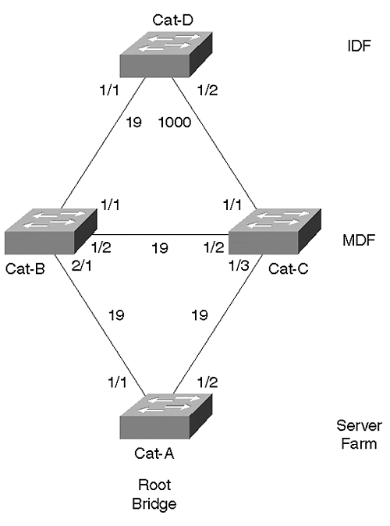
Cat-D is an IDF switch that is connected to two MDF switches (Cat-B and Cat-C). Although set spantree uplinkfast is a global command that applies to all VLANs, this section only analyzes a single VLAN: VLAN 2. Cat-A, the server farm switch, is the Root Bridge for VLAN 2. Cat-D has two uplink ports that are potential Root Port candidates. Utilizing the load balancing techniques discussed earlier, the cost on Port 1/2 has been increased to 1000 to force VLAN 2's traffic across the 1/1 link. Notice that Port 1/1 becomes the Root Port. UplinkFast is then enabled on Cat-D with the following command:

Cat-D> (enable) set spantree uplinkfast enable

This causes Cat-D to notice that Port 1/2 is Blocking and therefore constitutes a redundant connection to the Root Bridge. By making a note of this backup uplink port, Cat-D can set itself up for a quick rollover in the event that Port 1/1 fails. The list of potential uplink ports can be viewed with the show spantree uplinkfast command as in Example 7-15.

Example 7-15 Showing Forwarding and Backup Ports with UplinkFast
Cat-D> (enable) show spantree uplinkfast Station update rate set to 15 packets/100ms uplinkfast all-protocols field set to off VLAN port list ----------------------------------------------- 1 1/1(fwd),1/2
Port 1/1 is shown as the primary port (it is in the Forwarding state) and Port 1/2 is the backup. If three uplink ports exist, all three appear in the output.
It is important to recognize that UplinkFast is a Root Port optimization. It allows wiring closet switches to quickly bring up another Root Port in the event that the primary port fails.
Tip
UplinkFast is a Root Port optimization.

Therefore, it is futile to enable UplinkFast on a Root Bridge—because Root Bridges contain no physical Root Ports there is nothing for UplinkFast to optimize. In other words, only implement this feature on leaf-node switches sitting at the ends of the branches of your Spanning Tree. These leaf-node switches should not be used as a transit switches to reach the Root Bridge. So, as a general rule, only enable UplinkFast on your IDF wiring closet switches.
Tip
Do not enable UplinkFast on every switch in your network! Only enable UplinkFast on leaf-node Catalysts such as your IDF switches.

To enforce the requirement of leaf-node status, Cisco modifies several STP parameters when UplinkFast is enabled. Take a look at the output of the set spantree uplinkfast command in Example 7-16.

Example 7-16 set spantree uplinkfast Command Output
Cat-D> (enable) set spantree uplinkfast enable VLANs 1-1005 bridge priority set to 49152 The port cost and portvlancost of all ports set to above 3000 Station update rate set to 15 packets/100ms. uplinkfast all-protocols field set to off uplinkfast enabled for bridge
First, the Bridge Priority is modified to an unusually high value of 49,152. This causes the current switch to effectively take itself out of the election to become the Root Bridge. Second, it adds 3000 to the cost of all links. This is done to discourage other switches from using the current switch as a transit switch to the Root Bridge. Notice that neither of these actions limits STP failover in your network. The Bridge Priority modification only discourages other switches from electing this switch as the Root Bridge. If the other switches fail, this switch happily becomes the Root Bridge. Also, the increase to Path Cost only discourages other switches from using the current switch as a transit path to the Root Bridge. However, if no alternate paths are available, the current switch gleefully transfers traffic to and from the Root Bridge.
Notice the third line in the output in Example 7-16 (in bold). This is evidence of a subtle trick that is the crux of what UplinkFast is all about. It should probably be fairly obvious by now that a failure on Cat-D:Port-1/1 forces Cat-D to take all MAC addresses associated with Port 1/1 in the Bridging Table and points them to Port 1/2. However, a more subtle process must take place to convert the bridging tables in other switches. Why is this extra step necessary? Figure 7-23 shows the network with the left-hand link broken.

Figure 7-23 UplinkFast Behavior When the Primary Uplink Is Lost
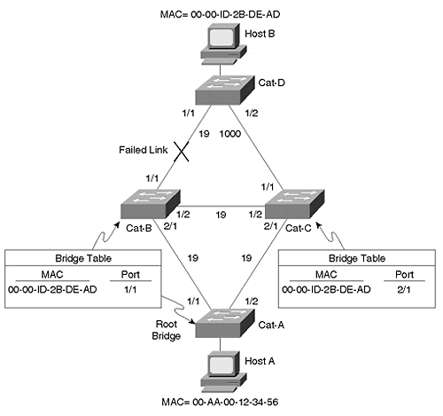
Cat-D changes MAC address 00-AA-00-12-34-56 (Host-A) to Port 1/2 so that it has a correct view of the network. However, notice that Cat-A, Cat-B, and Cat-C are still trying to send traffic for 00-00-1D-2B-DE-AD (Host-B) to the broken link! This is where the real ingenuity of UplinkFast comes in: Cat-D sends out a dummy multicast frame for the addresses in its local Bridging Table. One frame is sent for each MAC address that is not associated with one of the uplink ports. These packets are sent to a multicast 01-00-0C-CD-CD-CD destination address to ensure that they are flooded throughout the bridged network. Recall from Chapter 3 that multicast addresses are flooded as with broadcast frames. However, note that Cisco does not use the traditional multicast address of 01-00-0C-CC-CC-CC. Because this multicast address is reserved for single hop protocols such as Cisco Discovery Protocol (CDP), VLAN Trunk Protocol (VTP), Dynamic ISL (DISL), and Dynamic Trunk Protocol (DTP), Cisco devices have been programmed to not flood the 01-00-0C-CC-CC-CC. To avoid this behavior, a new multicast address needed to be introduced.
Each frame contains the source address of a different entry in the local Bridging Table. As these packets are flooded through the network, all of the switches and bridges make a note of the new interface the frame arrived on and, if necessary, adjust their bridging tables. By default, the Catalyst sends 15 of these dummy frames every 100 milliseconds, but this rate can be adjusted with the [rate station_update_rate] parameter (the number represents how many dummy updates to send every 100 milliseconds).
However, adjusting the rate parameter usually does not improve failover performance. Notice that only MAC addresses not learned over the uplinks are flooded. Because UplinkFast only runs on leaf-node switches where the vast majority of the MAC addresses in the bridging table are associated with the uplink ports, usually only a few hundred addresses require flooding. The default rate floods 450 to 600 addresses in the 3–4 second UplinkFast convergence period. Therefore, it only makes sense to increase the rate if you have more than about 500 devices connected to your wiring closet switch.
UplinkFast is an extremely effective and useful feature. It provides much faster convergence than any of the timer tuning techniques discussed earlier and is much safer. As long as you only deploy it in leaf-node switches, it can be a wonderful way to maintain the safety of STP while dramatically improving failover times in most situations.

BackboneFast
BackboneFast is a complementary (and patented) technology to UplinkFast. Whereas UplinkFast is designed to quickly respond to failures on links directly connected to leaf-node switches, it does not help in the case of indirect failures in the core of the backbone. This is where BackboneFast comes in.
Don't expect BackboneFast to provide the two to three second rollover performance of UplinkFast. As a Max Age optimization, BackboneFast can reduce the indirect failover performance from 50 to 30 seconds (with default parameters; and from 14 to 8 seconds with the tunable values set their minimums). However, it never eliminates Forwarding Delay and provides no assistance in the case of a direct failure (recall from the "Tuning Max Age" section that direct failures do not use Max Age).
Tip
BackboneFast is a Max Age optimization. It allows the default convergence time for indirect failures to be reduced from 50 seconds to 30 seconds.

As discussed in the previous section, UplinkFast should only be enabled on a subset of all switches in your network (leaf-node, wiring closet switches). On the other hand, BackboneFast should be enabled on every switch in your network. This allows all of the switches to propagate information about link failures throughout the network.
Tip
BackboneFast should be enabled on every switch in your network.

When a device detects a failure on the link directly connected to its Root Port, the normal rules of STP dictate that it begin sending Configuration BPDUs in an attempt to become the Root Bridge. What other devices do with these Configuration BPDUs depends on where the Designated Ports are located. If a Designated Port hears these inferior BPDUs, it immediately refutes them with a Configuration BPDU as discussed in the "Configuration BPDU" section earlier. If a non-Designated Port receives the inferior BPDU, it is ignored. However, in either case, the 802.1D standard does not provide a mechanism that allows switches receiving inferior BPDUs to make any judgments about the state of the network.
How does BackboneFast magically eliminate Max Age from the STP convergence delay? By taking advantage of the following two mechanisms:
- The first allows switches to detect a possible indirect failure.
- The second allows them to verify the failure.
The BackboneFast detection mechanism is built around the concept that inferior BPDUs are a signal that another bridge might have lost its path to the Root Bridge. BackboneFast's verification mechanism employs a request and response protocol that queries other switches to determine if the path to the Root Bridge has actually been lost. If this is the case, the switch can expire its Max Age timer immediately, reducing the convergence time by 20 seconds.
To detect the possible failure of the Root Bridge path, BackboneFast checks the source of the inferior BPDU. If the BPDU is from the local segment's Designated Bridge, this is viewed as a signal of an indirect failure. If the inferior BPDU came from another switch, it is discarded and ignored.
The verification process is more complex than the detection process. First, BackboneFast considers if there are alternate paths to the Root Bridge. If the switch receiving an inferior BPDU has no ports in the Blocking state (ports looped to itself are excluded), it knows that it has no alternate paths to the Root Bridge. Because it just received an inferior BPDU from its Designated Bridge, the local switch can recognize that it has lost connectivity to the Root Bridge and immediately expire the Max Age timer.
If the switch does have blocked ports, it must utilize a second verification mechanism to determine if those alternate paths have lost connectivity to the Root Bridge. To do this, the Catalysts utilize a Root Link Query (RLQ) protocol. The RLQ protocol employs two types of packets—RLQ Requests and RLQ Responses.
RLQ Requests are sent to query upstream bridges if their connection to the Root Bridge is stable. RLQ Responses are used to reply to RLQ Requests. The switch that originates the RLQ Request sends RLQ frames out all non-Designated Ports except the port that received the inferior BPDU. A switch that receives an RLQ Request replies with an RLQ Response if it is the Root Bridge or it knows that it has lost its connection to the Root Bridge. If neither of these conditions is true, the switches propagate the RLQ Requests out their Root Ports until the stability of the Root Bridge is known and RLQ Responses can be sent. If the RLQ Response is received on an existing Root Port, the switch knows that its path to the Root Bridge is stable. On the other hand, if the RLQ Response is received on some port other than the current Root Port, it knows that it has lost its connection to the Root Bridge and can immediately expire the Max Age timer. A switch propagates BPDUs out all Designated Ports until the switch that originated the RLQ Request is reached.
To illustrate this process, consider the simplified campus network shown in Figure 7-24.

Figure 7-24 BackboneFast Operation
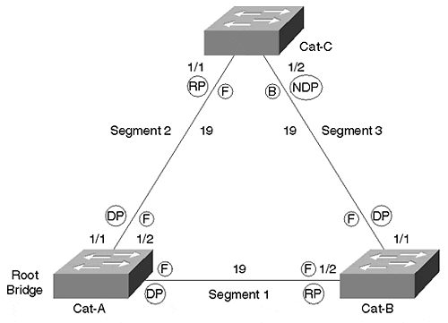
As discussed earlier, BackboneFast must be enabled on all three switches in this network. Assume that Cat-A is the Root Bridge. This results in Cat-B:Port-1/2 and Cat-C:Port-1/1 becoming Root Ports. Because Cat-B has the lower BID, it becomes the Designated Bridge for Segment 3, resulting in Cat-C:Port-1/2 remaining in the Blocking state.
Next, assume that Segment 1 fails. Cat-A and Cat-B, the switches directly connected to this segment, instantly know that the link is down. To repair the network, it is necessary that Cat-C:Port-1/2 enter the Forwarding state. However, because Segment 1 is not directly connected to Cat-C, Cat-C does not start sending any BPDUs on Segment 3 under the normal rules of STP until the Max Age timer has expired.
BackboneFast can be used to eliminate this 20-second delay with the following eight-step process (illustrated in Figure 7-25):

Figure 7-25 BackboneFast Steps to Eliminating the 20-Second Delay
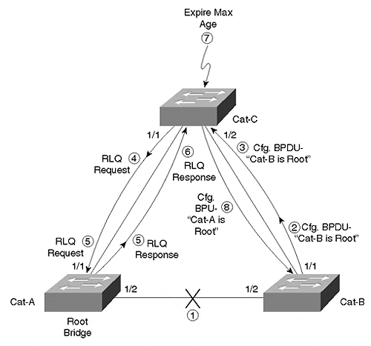
Step 1. Segment 1 breaks.
Step 2. Cat-B immediately withdraws Port 1/2 as its Root Port and begins sending Configuration BPDUs announcing itself as the new Root Bridge on Port 1/1. This is a part of the normal STP behavior (Steps 3–7 are specific to BackboneFast).
Step 3. Cat-C:Port-1/2 receives the first Configuration BPDU from Cat-B and recognizes it as an inferior BPDU.
Step 4. Cat-C then sends an RLQ Request out Port 1/1.
Step 5. Cat-A:Port-1/1 receives the RLQ Request. Because Cat-A is the Root Bridge, it replies with an RLQ Response listing itself as the Root Bridge.
Step 6. When Cat-C receives the RLQ Response on its existing Root Port, it knows that it still has a stable connection to the Root Bridge. Because Cat-B originated the RLQ Request, it does not need to forward the RLQ Response on to other switches.
Step 7. Because Cat-C has a stable connection to the Root Bridge, it can immediately expire the Max Age timer on Port-1/2.
Step 8. As soon as the Max Age timer expires in Step 7, the normal rules of STP require Port Cat-C:Port-1/2 to start sending Configuration BPDUs. Because these BPDUs list Cat-A as the Root Bridge, Cat-B quickly learns that it is not the Root Bridge and it has an alternate path to Cat-A.
Although this allows Cat-B to learn about the alternate path to the Root Bridge within several seconds, it still requires that Cat-C:Port-1/2 go through the normal Listening and Learning states (adding 30 seconds of delay to the convergence with the default values and 8 seconds with the minimum value for Forward Delay).
Tip
BackboneFast requires 4.1 or later code on the Catalyst 5000. All Catalyst 4000s and 6000s support BackboneFast.

Disabling Port Aggregation Protocol
In certain situations, the Port Aggregation Protocol (PAgP) can create "unexplainable STP delays" after link initialization. By default, current implementations of EtherChannel-capable ports reserve the first 15–20 seconds after link initialization for PAgP negotiations. As is discussed in Chapter 8, "Trunking Technologies and Applications," PAgP is a protocol that assists in correctly configuring bundles of Fast and Gigabit Ethernet links that act as one large EtherChannel pipe. PAgP defaults to a mode called the auto state where it looks for other EtherChannel-capable ports. While this process is occurring, STP is not aware that the link is even active. This condition can be observed with show commands. For example, show port displays a connected status for Port 1/1 immediately after it has been connected as a trunk link (see Example 7-17).

Example 7-17 show port Output Immediately After Port 1/1 Is Connected
Cat-D (enable) show port Port Name Status Vlan Level Duplex Speed Type ----- ------------------ ---------- ---------- ------ ------ ----- ------------ 1/1 connected trunk normal a-half a-100 10/100BaseTX 1/2 notconnect trunk normal a-half a-100 10/100BaseTX 3/1 notconnect 1 normal half 10 10BaseT 3/2 notconnect 1 normal half 10 10BaseT
However, if show spantree is issued at the same time, it still displays the port as not-connected as demonstrated in Example 7-18.

Example 7-18 show spantree Output Immediately After Port 1/1 is Connected
Cat-D (enable) show spantree 1 VLAN 1 Spanning tree enabled Spanning tree type ieee Designated Root 00-90-92-16-28-00 Designated Root Priority 100 Designated Root Cost 19 Designated Root Port 1/1 Root Max Age 20 sec Hello Time 2 sec Forward Delay 15 sec Bridge ID MAC ADDR 00-90-92-bf-70-00 Bridge ID Priority 32768 Bridge Max Age 20 sec Hello Time 2 sec Forward Delay 15 sec Port Vlan Port-State Cost Priority Fast-Start Group-method --------- ---- ------------- ----- -------- ---------- ------------ 1/1 1 non-connected 19 32 disabled 1/2 1 forwarding 19 32 disabled 3/1 1 not-connected 100 32 disabled 3/2 1 not-connected 100 32 disabled
After approximately 15–20 seconds, PAgP releases the port for use by the rest of the box. At this point, the port enters Listening, Learning, and then Forwarding. In short, because of PAgP, the port took 50 seconds instead of 30 seconds to become active.
Therefore, you should carefully consider the impact of PAgP in your campus implementations. First, it is advisable to use the desirable channeling state for links where an EtherChannel bundle is desired. Specifically, you should avoid using the on state because it hard-codes the links into a bundle and disables PAgP's capability to intelligently monitor the bundle. For example, all STP BPDUs are sent over a single link of the EtherChannel. If this one link fails, the entire bundle can be declared down if PAgP is not running in the auto or desirable states.
Tip
When using EtherChannel, code the ports to the desirable channeling state. Do not use the on state because it disables PAgP's capability to handle Spanning Tree failover situations.

However, in cases where EtherChannel is not in use, disabling PAgP can improve Spanning Tree performance dramatically. In general, campus networks benefit from disabling PAgP in three situations:
- End-Station Ports
- Servers using fault-tolerant NICs that toggle link state during failover
- Testing
End-stations can benefit from disabling PAgP on their switching ports. This can be especially noticeable when used in conjunction with PortFast. Even with PortFast enabled, EtherChannel-capable ports still require almost 20 seconds for activation because PAgP hides the port activation from STP. By disabling PAgP with the set port channelmod_num/port_numoff command, this 20-second delay can be almost eliminated, allowing PortFast to function as expected.
Fault-tolerant server NICs that toggle link state during failover can also benefit from a similar performance improvement (however, most fault-tolerant NICs do not toggle link). Otherwise, the PAgP delay needlessly interrupts server traffic for almost 20 seconds.
Finally, you should consider disabling PAgP on non-channel ports when performing STP performance. Otherwise, the 20-second PAgP delay can skew your results.
Tip
You might want to disable PAgP on EtherChannel-capable end-station and fault-tolerant server ports. This can also be useful when testing STP performance.

The good news is that this should not affect trunk link failover performance in production in most situations. For example, assume that Cat-D is using Port 1/1 and Port 1/2 as uplinks. If Port 1/1 fails, failover can start immediately because both links have been active for some time and are therefore past the initial PAgP lockout period. On the other hand, if Port 1/2 was acting as a cold standby and not connected when Port 1/1 failed, that is a different matter. In this case, you need to walk up and physically plug in Port 1/2 and PAgP does add to the STP failover time.

Useful STP Display Commands
Many Spanning Tree show commands have already been discussed. This section mentions some additional show spantree capabilities and introduces some extremely useful commands not discussed earlier.

General show spantree Guidelines
A quick look at the output of show spantree ? provides an overview of the options available for this powerful and useful command. Example 7-19 displays the output of show spantree ? from 4.5.1 Catalyst 5000 code.

Example 7-19 Online Help Listing of show spantree Options
Cat-D> (enable) show spantree ? Usage: show spantree [vlan] [active] show spantree <mod_num/port_num> show spantree backbonefast show spantree blockedports [vlan] show spantree portstate <trcrf> show spantree portvlancost <mod_num/port_num> show spantree statistics <mod_num/port_num> [vlan] show spantree statistics <trcrf> <trbrf> show spantree summary show spantree uplinkfast
The primary options are displayed in the following syntax listing:

show spantree [vlan | mod_num/port_num] [blockedports | active | statistics | summary]

These options (and more) are described in the following sections.

Using show spantree mod_num/port_num
It is extremely useful to utilize the mod_num/port_num option when analyzing Spanning Tree behavior on trunk links. It only lists port-level information and does not show the global and local timer values displayed with the VLAN parameter. For example, the command output in Example 7-20 looks at Port 1/1 which is configured as a trunk link carrying several VLANs.

Example 7-20 Output of show spantree mod_num/port_num
Cat-A> (enable) show spantree 1/1 Port Vlan Port-State Cost Priority Fast-Start Group-Method --------- ---- ------------- ----- -------- ---------- ------------ 1/1 1 listening 19 32 disabled 1/1 2 listening 16 32 disabled 1/1 3 listening 19 32 disabled 1/1 4 listening 16 32 disabled 1/1 5 listening 19 32 disabled 1/1 6 listening 16 32 disabled 1/1 7 listening 19 32 disabled 1/1 8 listening 19 32 disabled 1/1 9 listening 19 32 disabled 1/1 10 listening 19 32 disabled 1/1 1003 not-connected 19 32 disabled 1/1 1005 not-connected 19 4 disabled

Using show spantree active
Another useful show spantree option is the active keyword. The active keyword filters out all of the not-connected ports. This feature can be especially useful during deployments where many ports are not yet connected to end stations or on Catalysts with very high port densities. Example 7-21 shows some sample show spantree output using the active keyword.

Example 7-21 Output of show spantree active
Cat-A> (enable) show spantree 1 active VLAN 1 Spanning tree enabled Spanning tree type ieee Designated Root 00-90-92-16-18-00 Designated Root Priority 32768 Designated Root Cost 19 Designated Root Port 1/1 Root Max Age 20 sec Hello Time 2 sec Forward Delay 15 sec Bridge ID MAC ADDR 00-90-92-1B-CB-00 Bridge ID Priority 32768 Bridge Max Age 20 sec Hello Time 2 sec Forward Delay 15 sec Port Vlan Port-State Cost Priority Fast-Start Group-Method --------- ---- ------------- ----- -------- ---------- ------------ 1/1 1 forwarding 19 32 disabled 1/2 1 blocking 19 32 disabled 2/10 1 forwarding 100 32 disabled 2/23 1 listening 100 32 disabled
Although optional, it is best to get into the habit of always specifying the vlan parameter. Otherwise, it is easy to waste crucial time looking at output for VLAN 1 (the default) when you thought you were looking at some other VLAN. The same is also true of showspantree statistics and show spantree blockedports.

Using show spantree summary
The show spantree summary command can be useful for getting an overview of the port states on an entire Catalyst device. As illustrated in the output in Example 7-22, port states are listed for every VLAN along with totals for the entire device listed at the bottom.

Example 7-22 Output of show spantree summary
Cat-D> (enable) show spantree summary Summary of connected Spanning Tree ports by vlan Uplinkfast disabled for bridge. Vlan Blocking Listening Learning Forwarding STP Active ----- -------- --------- -------- ---------- ---------- 1 1 0 0 2 3 2 0 0 0 2 2 3 0 0 0 2 2 4 0 0 0 2 2 5 0 0 0 2 2 6 0 0 0 2 2 7 0 0 0 2 2 8 0 0 0 2 2 1003 1 0 0 1 2 1005 1 0 0 1 2 Blocking Listening Learning Forwarding STP Active ----- -------- --------- -------- ---------- ---------- Total 3 0 0 20 23

Using show spantree blockedports
The show spantree blockedports command can be used to quickly list all of the blocked (and therefore looped) ports on a Catalyst. The VLAN, trunk, and EtherChannel information is listed for every port. A total is presented on the last line. Example 7-23 displays some sample output from the show spantree blockedports command.

Example 7-23 Output of show spantree blockedports
Console> (enable) show spantree blockedports T = trunk g = group Ports Vlans ----- ---------- 1/2 1 2/14 1 Number of blocked ports (segments) in the system : 2

Using Spanning Tree Logging
In some situations, it is more important to see real-time feedback of Spanning Tree events. This can be enabled with the set logging command, as shown in Example 7-24. For example, set logging level spantree 7 displays STP state transitions. The logging feature was initially released in 2.2 NMP images. Early versions of this feature only show limited information such as when ports enter or leave the Forwarding and Blocking states. Later versions, such as 4.X, show all transitions (such as Listening and Learning mode). This command can also be used to send Spanning Tree transition information to a Syslog server for analysis later or to monitor STP on an ongoing basis.

Example 7-24 Output of Spanning Tree Logging
06/12/1999,19:33:45:SPANTREE-6: port 3/5 state in vlan 2 changed to blocking. 06/12/1999,19:33:45:SPANTREE-6: port 3/5 state in vlan 2 changed to Listening. 06/12/1999,19:33:51:SPANTREE-6: port 3/5 state in vlan 2 changed to Learning. 06/12/1999,19:33:58:SPANTREE-6: port 3/5 state in vlan 2 changed to forwarding.

Using show spantree statistics
If you have a yearning for detailed Spanning Tree information, the show spantree statistics command should keep you happy for a while. This command presents several screens full of information for a single VLAN on a single port. For instance, the output in Example 7-25 displays information for VLAN 1 on Port 1/1 of a Catalyst.

Example 7-25 Output of show spantree statistics
Cat-D> (enable) show spantree statistics 1/1 1 Port 1/1 VLAN 1 SpanningTree enabled for vlanNo = 1 BPDU-related parameters port Spanning Tree enabled state forwarding port_id 0x8001 port number 0x1 path cost 19 message age (port/VLAN) 0(20) designated_root 00-90-92-55-80-00 designated_cost 0 designated_bridge 00-90-92-55-80-00 designated_port 0x8001 top_change_ack FALSE config_pending FALSE port_inconsistency none PORT based information & statistics config bpdu's xmitted (port/VLAN) 1(393) config bpdu's received (port/VLAN) 402(804) tcn bpdu's xmitted (port/VLAN) 1(1) tcn bpdu's received (port/VLAN) 0(0) forward trans count 1 scp failure count 0 Status of Port Timers forward delay timer INACTIVE forward delay timer value 15 message age timer ACTIVE message age timer value 0 topology change timer INACTIVE topology change timer value 0 hold timer INACTIVE hold timer value 1 delay root port timer INACTIVE delay root port timer value 0 VLAN based information & statistics spanningtree type ieee spanningtree multicast address 01-80-c2-00-00-00 bridge priority 32768 bridge mac address 00-90-92-55-94-00 bridge hello time 2 sec bridge forward delay 15 sec topology change initiator: 1/1 last topology change occured: Fri Dec 11 1998, 14:25:00 topology change FALSE topology change time 35 topology change detected FALSE topology change count 1 topology change last recvd. from 00-00-00-00-00-00 Other port-specific info dynamic max age transitions 0 port bpdu ok count 0 msg age expiry count 0 link loading 1 bpdu in processing FALSE num of similar bpdus to process 0 received_inferior_bpdu FALSE next state 3 src mac count: 0 total src mac count 0 curr_src_mac 00-00-00-00-00-00 next_src_mac 00-00-00-00-00-00 channel_src_mac 00-00-00-00-00-00 channel src count 0 channel ok count 0
The output of show spantree statistics is broken into five sections. Several of the more useful fields are discussed here. The message age (port/VLAN) field under the BPDU-related parameters section displays two values. The first value (outside the parentheses) displays the age of the most recently received BPDU plus any time that has elapsed since it arrived. This can be useful to determine if the flow of Configuration BPDUs has stopped arriving from the Root Bridge. The second value (inside the parentheses) displays the Max Age for the VLAN, currently at the default of 20 seconds in the sample output. This is the locally configured value, not the value received from the Root Bridge (and actually in use).
The PORT based information & statistics presents some very useful BPDU counter statistics. The first two lines display the number of Configuration BPDUs transmitted and received. The next two lines display the same information for TCN BPDUs. Each line contains two values. The first value (outside the parentheses) displays the number of BPDUs transmitted or received on that port for the specified VLAN (if it is a trunk). The second value (inside the parentheses) shows the total number of BPDUs received for the entire VLAN (all ports).
If you are experiencing STP problems, this information can be used to verify that BPDUs are flowing. However, notice that both ends of a link generally do not increment both the transmit and the receive counters. During steady state processing, only the Designated Port increments the Configuration BPDU transmit counter, whereas the Root Port (or Ports) at the other end only increments the receive counter. The BPDU counters can be invaluable when troubleshooting situations where a link has failed in such a way that traffic cannot flow in both directions. Without this information, it can take days to narrow down the source of the instability.
Tip
Use the BPDU transmit and receive counters to troubleshoot link failure problems. Also, Cisco's UniDirectional Link Detection (UDLD) can be very useful.

The VLAN based information & statistics section contains helpful information on topology changes. Last topology change occurred shows the time and date that the last change took place. The topology change count field shows the total number of topology changes that have occurred since Spanning Tree initialized on this port. The topology change last recvd. from field shows the port MAC address (the MAC address used in the 802.3 header, not the MAC address used for the BID) of the last bridge or switch to send the current bridge a TCN BPDU. Use these fields to track instability caused by excessive Topology Change Notifications. However, notice that unless you are using PortFast on all of your end-station ports, every time a PC or workstation boots or shuts down it generates a TCN BPDU.
Tip
Use the topology change information in the VLAN based information & statistics section to track down TCN BPDU problems.

Per-VLAN Spanning Tree Plus
As discussed in Chapter 5, 802.1Q has defined standards-based technologies for handling VLANs. To reduce the complexity of this standard, the 802.1 committee specified only a single instance of Spanning Tree for all VLANs. Not only does this provide a considerably less flexible approach than the Per-VLAN Spanning Tree (PVST) adopted by Cisco, it creates an interoperability problem. To address both of these issues, Cisco introduced the Per-VLAN Spanning Tree Plus (PVST+) protocol in 4.1 code on the Catalyst 5000s (all 4000s and 6000s support PVST+). This feature allows the two schemes to interoperate in a seamless and transparent manner in almost all topologies and configurations.
There are both advantages and disadvantages to using a single Spanning Tree. On the upside, it allows switches to be simpler in design and place a lighter load on the CPU. On the downside, a single Spanning Tree precludes load balancing and can lead to incomplete connectivity in certain VLANs (the single STP VLAN might select a link that is not included in other VLANs). Given these tradeoffs, most network designers have concluded that the downsides of having one Spanning Tree outweigh the benefits.
Note
Although the initial release of 802.1Q only specified a single instance of the Spanning-Tree Protocol, the IEEE is working on multiple instances of STP in the 802.1s working group.

PVST+ Network Region Types
PVST+ allows for three types of regions in the network:
- A group of traditional (pre-4.1) Catalysts form a PVST region with each VLAN using a separate instance of the Spanning-Tree Protocol.
- Pure 802.1Q switches use a single instance of the Spanning-Tree Protocol, the Mono Spanning Tree (MST). A group of these switches forms an MST region.
- Catalysts running 4.1 and later code form a PVST+ region.
Given that pure 802.1Q switches only support 802.1Q-style trunks and PVST switches only support ISL trunks, these regions can only be connected in a limited set of combinations:
- PVST and PVST+ regions can connect over ISL trunk links.
- MST and PVST+ regions can connect over an 802.1Q trunk.
Notice that an MST and PVST region cannot be connected via a trunk link. Although it is possible to provide a non-trunk connection between the two regions by using an access (non-trunk) link, this is of limited usefulness in real-world networks. Figure 7-26 illustrates the three types of STP regions and potential linkages.

Figure 7-26 Three Types of Regions Supported under PVST+
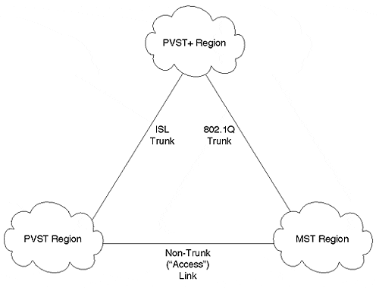
Because it provides interoperability between the other two types of regions, a PVST+ region is generally used in the backbone. It connects to MST regions via 802.1Q trunks and PVST regions via ISL links. However, more flexible configurations are allowed. For example, two PVST+ regions can connect via an MST backbone region.

PVST+ Mapping and Tunneling
PVST+ utilizes two techniques to provide transparent STP support across the three types of regions:
- Mapping
- Tunneling
Mapping is used between PVST and PVST+ regions. Each Spanning Tree in a PVST region maps to a separate Spanning Tree in PVST+ on a one-to-one basis. The same occurs in the reverse direction. This process is both simple and obvious.
On the other hand, when converting between MST and PVST+ regions, both mapping and tunneling must be used. The single Spanning Tree used in the MST region maps to a single Spanning Tree in the PVST+ region. This Spanning Tree is referred to as the Common Spanning Tree (CST) and uses VLAN 1. When going in the opposite direction, all Spanning Trees other than the CST belonging to VLAN 1 use tunneling. The BPDUs for these VLANs are flooded throughout the MST region and reach other PVST+ bridges on the far side.
How does Cisco implement the tunneling approach that allows these PVST+ BPDUs to be flooded? In the case of mapped VLANs, the BPDUs are sent to the well-known STP MAC address of 01-80-C2-00-00-00. All bridges conforming to the 802.1D specification do not flood these frames. Rather, the frames are forwarded to the CPU for STP processing. If necessary, the STP process generates new BPDUs to pass on to other devices. If the PVST+ BPDUs were sent into the MST region using this MAC address, they would only travel as far as the first bridge or switch. Because MST devices do not understand multiple instances of the Spanning-Tree Protocol, these BPDUs would be dropped. However, because PVST+ uses a different multicast MAC address, the MST devices would flood the BPDUs as if they were normal data. As these BPDUs reach other PVST+ switches on the far side of the MST region, they can be processed as if they were sent to the well-known MAC address.
To accomplish this flooding process, Cisco has utilized the destination MAC address 01-00-0C-CC-CC-CD. Notice that this address differs from the usual Cisco multicast address used by CDP, VTP, DISL, PAgP, and DTP: 01-00-0C-CC-CC-CC. Although these only differ by one bit, the difference is critical. Just as all 802.1D bridges absorb frames sent to 01-80-C2-00-00-00 for processing (in other words, they are regenerated, not flooded), all Cisco devices absorb 01-00-0C-CC-CC-CC for processing. If the usual Cisco Multicast were used, all existing Catalyst devices would not flood the PVST+ BPDUs, breaking the tunneling process. However, by using a new multicast address, older Cisco bridging devices flood the BPDUs as normal data. As mentioned in the previous paragraph, also notice that the CST BPDUs must be sent to the well-known MAC of 01-80-C2-00-00-00 (this is the MAC addresses specified for STP in the 802.1D specification) so that they can be processed normally by the devices in the MST region.

PVST+ and Spanning Tree Load Balancing
An interesting question arises when using PVST+: How do you implement STP load balancing? Fortunately, most of the techniques discussed earlier work the same under PVST+ as they were explained under the PVST rules used earlier. The most significant difference has to do with the mechanics of the tunneling process. Specifically, when MST switches flood the PVST+ BPDUs, they are only flooded out ports that are in the Forwarding state. Not only can this delay the initial propagation of PVST+ BPDU through the MST region, it can affect STP load balancing. For example, consider Figure 7-27, the simplified campus backbone used throughout this chapter.

Figure 7-27 PVST+ Load Balancing
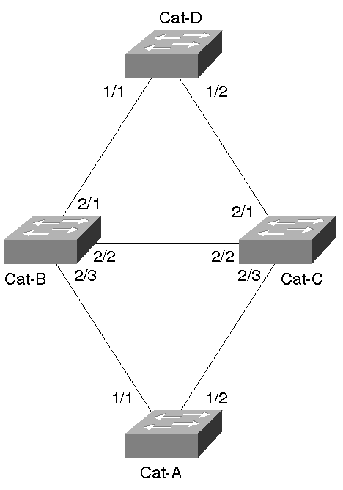
Five basic combinations of MST, PVST, and PVST+ switches can be used in this network:
- All switches are PVST devices—
This is the case discussed in the "Spanning Tree Load Balancing" section earlier. All of the load balancing techniques covered in that section obviously work here.
- All switches are PVST+ devices—
Load balancing can be implemented using exactly the same techniques as with PVST switches. The PVST+ and CST BPDUs are handled without any user configuration.
- All switches are MST devices—
No STP load balancing is possible under the current version of 802.1Q.
- An IDF switch is an MST device and remaining devices are PVST+ devices—
For PVST+ BPDUs and traffic to pass through both uplink ports on the IDF switch, both ports need to be in the STP Forwarding state. Beyond that, normal STP load balancing techniques can be utilized.
- An MDF switch is an MST device and remaining devices are PVST+ devices—
For PVST+ BPDUs and traffic to pass through all ports of the MDF switch, all of the ports must be placed in the Forwarding state. After that has been accomplished, normal STP load balancing can be done.
In short, PVST+ allows all of the usual Spanning Tree load balancing techniques to be used with one exception—all inter-switch ports on MST devices should be in the Forwarding state.
Note
Load balancing might be possible if some MST ports are Blocking. However, the load balancing design requires careful analysis. In general, it is easiest to design the network to have all inter-switch MST ports in the Forwarding state (if possible).

Two problems arise when the MST ports are not forwarding:
- PVST+ BPDUs are only flooded out a subset of the ports, and therefore only learn a subset of the topology.
- Blocking MST ports destroy the capability to implement load balancing. Recall that when an MST switch puts a port in the Blocking state, it blocks that port for allVLANs. Because this forces all traffic to use a single path, load balancing is no longer possible.
Tip
The mapping and tunneling aspects of PVST+ require no user configuration or intervention. This allows plug-and-play interoperability. However, load balancing might require some extra STP tuning to force the MST ports into the Forwarding state.

It can be tricky to meet the requirement that all ports on the MST switches forward while also distributing the traffic across multiple paths. A couple of examples illustrate this point. First, consider the case of an MDF MST switch as shown in Figure 7-28. Cat-B has been replaced by Sw-B, a generic 802.1Q MST switch.

Figure 7-28 MDF MST Switch Load Balancing
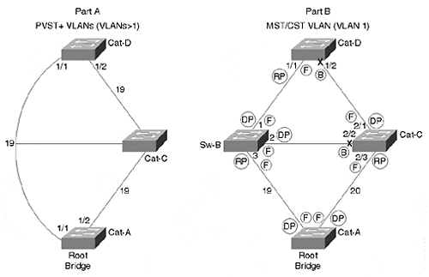
Part A in Figure 7-28 illustrates the tunneling process of PVST+ BPDUs through an MST switch (this is used for VLANs other than VLAN 1). Because the MST switch floods the PVST+ BPDUs out all inter-switch ports (assuming that the requirement of all ports Forwarding is met), it is as though the MST switch does not exist. An interesting consequence of this is that the left path appears to only have a cost of 19, whereas the right path has the usual cost of 38 (19+19). In other words, Cat-A, the Root Bridge, originates Configuration BPDUs with a cost of zero. These BPDUs arrive without any modification on Cat-D:Port-1/1 where the cost is increased to 19. On the right link, Cat-C receives the BPDUs and increases the Root Path Cost to 19. When Cat-D:Port-1/2 receives these, it increases the Root Path Cost to 38. This issue is easily overcome by increasing cost to some large value such as 1000 on the link you do not want the traffic to take (this is another example of a case where using the default portvlancost behavior of lowering the cost by one does not work as discussed in the earlier section "Decreasing Path Cost for Load Balancing"). For example, traffic for VLAN 3 could be forced to take the right link by increasing VLAN 3's Path Cost on Cat-D:Port-1/1 to 1000 (the cost of the right path would remain 38 and be more attractive).
Part B in Figure 7-28 illustrates the active topology seen in VLAN 1, the MST/CST VLAN. This is the VLAN where the STP parameters must be tuned to meet the requirement that all ports on the MST switch be Forwarding. One easy way to meet this requirement is to make Sw-B the Root Bridge for VLAN 1. In a simple topology such as that shown in Figure 7-28, this is probably the most effective approach. However, a more flexible technique is generally required for larger networks. Part B shows a solution that can be utilized in these cases (note that Cat-A is the Root Bridge). Sw-B:Port-1 and Sw-B:Port-3 are Forwarding by default (Sw-B:Port-1 becomes a Designated Port and Sw-B:Port-3 becomes the Root Port). Sw-B:Port-2, on the other hand, might or might not become a Designated Port (if Cat-C has a lower BID, Cat-C:Port-2/2 wins the election). To eliminate this chance and force Sw-B:Port-2 to win the Designated Port election, the Path Cost of Cat-C:Port-2/3 can be increased from 19 to 20 (or something even higher).
Tip
Load balancing generally requires all inter-switch ports on MST switches to be in the Forwarding state.

Figure 7-29 illustrates the case of an IDF MST switch. Cat-B has been put back into service and the generic 802.1Q switch has been relocated to the IDF wiring closet in place of Cat-D (it is called Sw-D).

Figure 7-29 IDF MST Switch Load Balancing
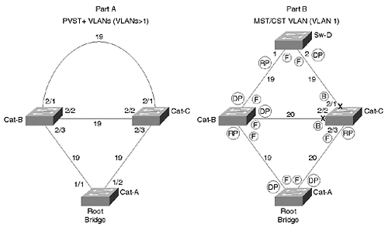
In this case, both uplink ports on Sw-D must be Forwarding. However, to ensure this behavior, one of Sw-D's ports must become a Root Port and the other must become a Designated Port. This can be accomplished by increasing the cost on Cat-C:Port-2/2 and Cat-C:Port-2/3 enough to force Cat-C:Port-2/1 into the Blocking state (because Sw-D:Port-2 has the most attractive port for the Cat-C to Sw-D segment). Now that the MST switch has all inter-switch ports in the Forwarding state, load balancing can be addressed. In this case, Cat-B should be configured to forward half of the VLANs (for example, the even VLANs) while Cat-C handles the other half (the odd VLANs). This can be done by increasing (or decreasing) the Path Cost on Ports 2/3 of Cat-B and Cat-C for alternating VLANs.
Note
Note that the Path Cost on Cat-C:Port-2/3 needs to be set between 20 and 37 for the topology to work as described in Figure 7-29. If it were set lower, Cat-C:Port-2/1 would have a lower Root Path Cost than Sw-D:Port-2, causing Sw-D:Port-2 to enter the Blocking state. On the other hand, if Cat-C:Port-2/3's Path Cost were set to higher than 37, Cat-C:Port-2/1 would become the Root Port for Cat-C, causing Cat-C:Port-2/3 to enter the Blocking state.

Disabling STP
It might be necessary to disable Spanning Tree in some situations. For example, some network administrators disable STP in frustration after not being able to resolve STP bugs and design issues. Other people disable STP because they have loop-free topologies. Some shops resort to disabling STP because they are not aware of the PortFast feature (not to mention its interaction with PAgP as discussed earlier).
If you do need to disable STP, Catalysts offer the set spantree disable command. On most Catalyst systems, STP can be disabled on a per-VLAN basis. For example, set spantree disable 2 disables STP for VLAN 2. However, don't forget that this disables STP for all ports in the specified VLAN—Layer 2 Catalyst switches such as the 4000s, 5000s, and 6000s currently do not offer the capability to disable STP on a per-port basis. Example 7-26 shows the use of the set spantree disable command to disable STP for VLAN 1 on Cat-A.

Example 7-26 Disabling STP for VLAN 1
Cat-A> (enable) set spantree disable 1 Spantree 1 disabled
If you are using certain Layer 3 switching technologies such as the NetFlow Feature Card, STP can only be disabled for an entire device (all VLANs).
Tip
STP cannot be disabled per port on Layer 2-oriented Catalyst equipment such as the 4000s, 5000s, and 6000s. When these Catalysts are not using a NFFC, you are allowed to disable STP per VLAN, but this applies to all ports in the VLAN on the specified device. Because devices such as the Catalyst 8500 use the full router IOS, you have complete control over where Spanning Tree runs (through the use of bridge-group statements).

Disabling STP on an entire device can be accomplished with the set spantree disable all command.
However, it is generally better to use features such as PortFast, UplinkFast, Layer 3 switching, and a scalable design than it is to completely disable Spanning Tree. When Spanning Tree is disabled, your network is vulnerable to misconfigurations and other mistakes that might create bridging loops.
Tip
Don't take disabling STP lightly. If loops are formed by mistake, the entire network can collapse. In general, it is preferable to utilize features such as UplinkFast than to entirely disable STP.

One of the more common places where Spanning Tree can be disabled is when using an ATM campus core. Because LANE naturally provides a loop-free environment, some ATM-oriented vendors leave Spanning Tree disabled by default. However, for this to work, you must be very careful to avoid loops in the Ethernet portion of your network. Besides preventing loops between end-user ports, you generally must directly connect every IDF switch to the ATM core (in other words, redundant Ethernet links cannot be used from the MDF closets to the IDF closets because they would form loops).
Finally, notice that when STP is disabled on Layer 2 Catalyst equipment such as the 4000s, 5000s, and 6000s, BPDUs are flooded through the box. In other words, as soon as Spanning Tree is disabled, the 01-80-C2-00-00-00 multicast address is again treated as a normal multicast frame (rather than being directed to the Supervisor where the frames are absorbed and possibly regenerated). The net effect of this is that Catalysts with Spanning Tree disabled are invisible to neighboring switches that are still running the protocol. To these switches, the Catalyst with STP disabled is indistinguishable from a Layer 1 hub (at least as far as STP goes).

Tips and Tricks: Mastering STP
This section summarizes some of the advice given in earlier sections while also introducing some other STP best practices.
Manually position Root Bridges.
Leaving Root Bridge placement to chance can dramatically affect the stability and scalability of your network. For more information, see the sections "Using Spanning Tree in Real-World Networks" and "Deterministic Root Bridge Placement" in Chapter 6.
Always have at least one backup Root Bridge.
If you design your network around a single Root Bridge, all of your carefully laid plans can unravel when the Root Bridge fails. All Layer 2 networks should have at least one backup Root Bridge. Large networks might require more than one.
Try to locate Root Bridges on devices near heavily used traffic destinations.
For flat networks lacking sufficient Layer 3 hierarchy, this usually means placing the Root Bridges for all VLANs on a pair of redundant switches at the server farm entrance. For more hierarchical networks, collocate the Root Bridges with the routers acting as the default gateways for the end-user segments (see Chapters 11, 15, and 17 for more information).
Diagram your primary and backup topologies.
Most network managers recognize the value in having network diagrams. However, most of these diagrams only show the Layer 3 topology. Furthermore, tools such as HP OpenView tend to be very Layer 3 centric (although this is starting to change). Unfortunately, these Layer 3 diagrams tell you nothing about your Layer 2 topology—it all appears as one big subnet. CiscoWorks for Switched Internetworks (CWSI) in CiscoWorks 2000 has a simplistic but effective STP mapping tool.
Network managers running a large switched infrastructure should consider placing the same care and effort into Layer 2 diagrams as they do with Layer 3 diagrams. When doing this, be sure to capture the primary and back up active Spanning Tree topologies. The diagram should indicate which ports are Forwarding and which ports are Blocking for each VLAN. Knowing this ahead of time can be a huge lifesaver when the network is down. It can be confusing enough just to figure out your STP topology on a calm day—trying to figure it out when the network is down is no fun at all!
Tip
Many CWSI/CiscoWorks 2000 users are not aware that it contains a Spanning Tree mapping tool. To use it, first pull up VLAN Director. Then select a VTP domain. Then pick a VLAN in that domain. This highlights the nodes and links that participate in the VLAN. It also brings up the VLAN section (it has a yellow light bulb next to it). Click the Spanning Tree checkbox and the Blocking ports, which are marked with a sometimes-hard-to-see X.

Update your design after adding to the network.
After carefully implementing load balancing and Root Bridge failover strategies, be sure to evaluate the impact of network additions and modifications. By adding devices and paths, it is easy for innocent-looking changes to completely invalidate your original design. Also be sure to update your documentation and diagrams. This is especially true if you are using a flat-earth design (see the section "Campus-Wide VLANs Model" in Chapter 14).
Avoid timer tuning in flat designs.
Unless you have a narrow Spanning Tree diameter and a very controlled topology, timer tuning can do more harm than good. It is usually safer and more scalable to employ techniques such as UplinkFast and BackboneFast.
Max Age tuning is less risky than Forward Delay tuning. Although overly-aggressive Max Age tuning can lead to excessive Root Bridge, Root Port, and Designated Port elections, it is less dangerous than overly-aggressive Forward Delay tuning. Because Forward Delay controls the time a device waits before placing ports in the Forwarding state, a very small value can allow devices to create bridging loops before accurate topology information has had time to propagate. See the sections "Tuning Max Age" and "Tuning Forward Delay" earlier in this chapter for more information.
If you do resort to timer tuning, consider using the set spantree root macro. This macro sets Spanning Tree parameters based on the recommended formulas at the end of the 802.1D spec. For more information, see the section "Using A Macro: set spantree root" in Chapter 6.
Use timer tuning in networks using the multilayer design model.
Because this approach constrains the Layer 2 topology into lots of Layer 2 triangles, consider using STP timer tuning in networks using the multilayer design model. In general, it is recommended to use the set spantree root command and specify a diameter of 2–3 hops and a Hello Time of two seconds. See the section "Timer Tuning" in Chapter 15 for more detailed information.
Utilize Root Bridge placement load balancing in networks employing MLS and the multilayer design model.
This chapter discussed the importance of using Layer 3 switching to limit the size of your Spanning Tree domains. Chapters 11, 14, 15, and 17 look at the use of various approaches to Layer 3 switching and make some specific recommendations on how to use this technology for maximum benefit. Chapter 14 details one of the most successful campus design architectures, the so-called multilayer model. When implemented in conjunction with Cisco's MLS/NFFC, the multilayer model seeks to reduce Spanning Tree domains to a series of many small Layer 2 triangles. Because these triangles have very predictable and deterministic traffic flows, they are very well suited to using the Root Bridge Placement form of STP load balancing. In general, the Root Bridges should be located near or collocated with the default gateway router for that VLAN.
Port/VLAN cost is the most flexible STP load balancing technique.
Other than Root Bridge placement, which can be useful in networks with well-defined traffic patterns for each VLAN, port/VLAN cost load balancing is the preferable option. In general, it should be used in all situations other than the case mentioned in the previous tip. For details, see "Load Balancing with Port/VLAN Cost" earlier in this chapter.
Spanning Tree load balancing requires that multiple VLANs be assigned to IDF wiring closet switches.
Although assigning a single VLAN to IDF switches can make administration easier, it prevents STP load balancing from being possible. In some cases, non-STP load balancing techniques such as MHSRP and EtherChannel might still be possible with a single IDF VLAN.
Use a separate management VLAN.
Just like end-stations, Catalysts must process all broadcast packets in the VLAN where they are assigned. In the case of a Layer 2 Catalyst, this is the VLAN where SC0 is placed. If this VLAN contains a large amount of broadcast traffic, it can then overload the CPU and cause it to drop frames. If end-user traffic is dropped, no problem. However, if STP (or other management) frames are dropped, the network can quickly destabilize. Isolating the SC0 logical interfaces in their own VLAN protects them from end-user broadcasts and allows the CPU to focus only on important management traffic. In many cases, the factory default VLAN (VLAN 1 for Ethernet) works well as the management VLAN. Chapter 15 discusses management VLAN design issues and techniques.
Minimize Layer 2 loops in the management VLAN.
Many networks contain lots of redundancy in the management VLAN. The thought is that it prevents failovers from isolating switch management capabilities. Unfortunately, this can also destabilize the network. In networks with lots of management VLAN loops, all it takes is a single switch to become overloaded or run into an STP bug. If this switch then opens up a bridging loop in the management VLAN, suddenly neighboring bridges see a flood of broadcast and multicast traffic. As this traffic inevitably overloads the neighboring switches, they can create additional bridging loops. This phenomenon can pass like a wave across the entire network with catastrophic results. Although it might only directly effect VLAN 1, by disabling the CPUs in all bridges and switches, it effectively shuts down the entire Layer 2 network. To avoid these problems, it is advisable to use Layer 3 routing, not Layer 2 bridging, to provide redundancy in the management VLAN. This point is discussed further in Chapter 15.
Use Layer 3 switching to reduce the size of Spanning Tree domains.
Now that you are armed with a truck-load of STP knowledge, creating scalable and flexible STP designs should be a breeze! However, this knowledge should also lead you to the conclusion that excessively large Spanning Tree domains are a bad idea. Small STP domains provide the best mix of failover performance and reliability. See Chapters 11, 14, 15, and 17 for more information.
Try to design your network such that Spanning Tree domains consist of MDF-IDF-MDF triangles.
This maximizes STP's value as a Layer 2 failover feature minimizes any scalability concerns.
Use PortFast on end-station ports to reduce Topology Change Notifications.
Not only can PortFast eliminate problems associated with devices that boot and access the network quickly, it reduces the number of Topology Change Notifications in the network. See the "PortFast" section in the chapter for more information.
Use UplinkFast to improve IDF wiring closet failover time.
UplinkFast is an extremely effective and clever STP optimization that reduces most wiring closet failover times to two or three seconds. See the "UplinkFast" section in this chapter for more information.
PVST+ load balancing requires all inter-switch ports on MST switches to be in the Forwarding state.
PVST+ allows traditional PVST Catalysts to interoperate with 802.1Q switches that only use a single Spanning Tree (MST). Best of all, it does this without any additional configuration! However, it might require careful planning to maintain effective STP load balancing. See the "PVST+" section of this chapter for more information.
Always specify the VLAN parameter with Spanning Tree commands to avoid accidental changes to VLAN 1.
Many of the Spanning Tree set and show commands allow you to omit the VLAN parameter. When doing so, you are implying VLAN 1. To avoid confusion and unintentional modifications to VLAN 1, it is best to get in the habit of always specifying this parameter.
The original implementations of Fast EtherChannel in 2.2 and 2.3 NMP images did not support STP over EtherChannel.
Spanning Tree still viewed the link as two or four separate ports and would block all but one (obviously defeating the purpose of EtherChannel). The limitation was solved in 3.1 and later versions of code. Don't be misled by older or incorrect documentation that does not reflect this enhancement—using STP over EtherChannel is generally a good idea.
Utilize the "desirable" EtherChannel mode for maximum Spanning Tree stability.
When using the on mode, it is possible for the entire channel to be declared down when only the single link carrying STP failed. See Chapter 8 for more information on EtherChannel technology.
Be certain that you do not overload your CPU with Spanning Tree calculations.
Keep the total number of logical ports below the values specified in Table 7-4.

Table 7-4. Maximum Logical Ports
Cat 5000 Supervisor | Max Logical Ports
Supervisor I | 400
Supervisor II | 1500
Supervisor III | 3500
Use the following formula to calculate the number of logical ports on your devices:
Logical Port = number VLANs on non-ATM trunks + (2 × number VLANs on ATM trunks) + number non-trunk ports
In other words, you want to add up the total number of VLANs on every port in your box. ATM VLANs (these are called ELANs; see Chapter 9, "Trunking with LAN Emulation" ) are more heavily weighed by counting them twice.
For example, consider a Catalyst 5000 MDF switch with 100 Ethernet trunk ports, each of which carry 25 VLANs. Also assume that the MDF switch is 32 Ethernet-attached servers using non-trunk links. In this case, the total number of logical ports would be:
2,532 = (100 trunks × 25 VLANs) + 32 non-trunk ports
Although this is by no means the largest MDF switch possible with Catalyst equipment, notice that it requires a Supervisor III. If the trunks were ATM trunks, the total number of logical ports swell to 5,032—more than even a Catalyst 5000 Supervisor III can handle.
Finally, note that this calculation assumes a Hello Time of two seconds. If you have decreased your Hello Time to one second to speed convergence, double the value you calculate in the formula. For instance, the number of Ethernet logical ports in the previous example would be 5,032, and the number of ATM logical ports would swell to 10,064!

Exercises
This section includes a variety of questions and hands-on lab exercises. By completing these you can test your mastery of the material included in this chapter as well as help prepare yourself for the CCIE written and lab tests.

Review Questions
1: | Label the port types (RP=Root Port, DP=Designated Port, NDP=non-Designated Port) and the STP states (F=Forwarding, B=Blocking) in Figure 7-30. The Bridge IDs are labeled. All links are Fast Ethernet. Assume that there is only a single VLAN and that the portvlanpri command has not been used.  Figure 7-30 Two Back-to-Back Catalysts with Crossed Links  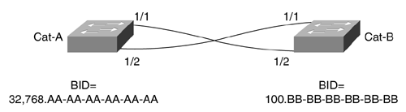
2: | When do bridges generate Configuration BPDUs?
3: | When do bridges generate Topology Change Notification BPDUs?
4: | How many Spanning Tree domains are shown in Figure 7-31? Assume that all of the switches are using ISL trunks and PVST Spanning Tree.  Figure 7-31 Multiple Spanning Tree Domains  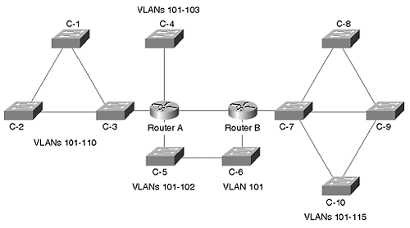
5: | When is the Root Bridge placement form of STP load balancing most effective? What command(s) are used to implement this approach?
6: | When is the Port Priority form of STP load balancing useful? What command(s) are used to implement this approach? What makes this technique so confusing?
7: | When is the Bridge Priority form of STP load balancing useful? What command(s) are used to implement this approach? What makes this technique so confusing?
8: | When is the portvlancost form of load balancing useful? What is the full syntax of the portvlancost command? What is the one confusing aspect of this technique?
9: | What technology should be used in place of portvlanpri?
10: | What are the components that the default value of Max Age is designed to account for? There is no need to specify the exact formula, just the major components captured in the formula.
11: | What are the components that the default value of Forwarding Delay is designed to account for? There is no need to specify the exact formula, just the major components captured in the formula.
12: | What are the main considerations when lowering the Hello Time from the default of two seconds to one second?
13: | Where should PortFast be utilized? What does it change about the STP algorithm?
14: | Where should UplinkFast be utilized? In addition to altering the local bridging table to reflect the new Root Port after a failover situation, what other issue must UplinkFast address?
15: | Where should BackboneFast be utilized?
16: | Where is PVST+ useful?
17: | Can MST regions be connected to PVST regions?
18: | Can you disable STP on a per-port basis?
19: | Why is it important to use a separate management VLAN?
20: | What happens if UplinkFast sends the fake multicast frames to the usual Cisco multicast address of 01-00-0C-CC-CC-CC?

Hands-On Lab
Complete an STP design for the network shown in Figure 7-32.

Figure 7-32 A Three-Building Campus Design
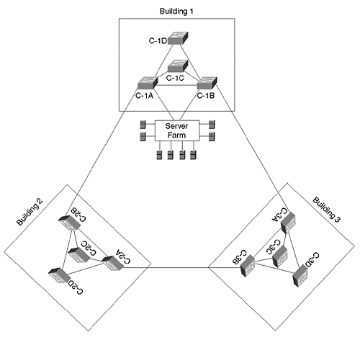
Figure 7-32 shows a three-building campus. Each building contains two MDF switches (A and B) and two IDF switches (C and D). The number of IDF switches in each building is expected to grow dramatically in the near future. The server farm has its own switch that connects to Cat-1A and Cat-1B. The network contains 20 VLANs. Assume that each server can be connected to a single VLAN (for example, the SAP server can be connected to the Finance VLAN). Assume that all links are Fast Ethernet except the ring of links between the MDF switches, which are Gigabit Ethernet.
Be sure to address the following items: STP timers, Root Bridges, Load Balancing, failover performance, and traffic flows. Diagram the primary and backup topologies for your design.
Note
This design utilizes what Chapters 14 and 15 refer to as the campus-wide VLANs design model. In general, this design is not recommended for large campus designs. However, it is used here because it makes extensive use of the Spanning-Tree Protocol. For more information on campus-wide VLANs and other design alternatives, please consult Chapters 11, 14, 15, and 17.

